Job Aid

How to Match Students: Recipients

Purpose
                - This document outlines the Match Student feature in EIS which is used for:
- Nominal Roll Student and Education Staff Census (NR) Report, and
- Annual Register of Post-Secondary Education Students (PSE) Report.
                - The purpose of Match Student is to reconcile student records in Nominal Roll and Post-Secondary Education reports against existing records in EIS or IRS using matching and merging functionalities.

When is Match Student Used?
                - The Match Student feature is used when:
- A new student is being added to the report and you need to check to see if there is an existing student record. Refer to the Adding a New Student section below for more details.
- The report has been rolled-over or uploaded into EIS and a student is displayed as ‘not matched’ () on the Clients Served screen. Refer to the Clients Served section for more details.

Adding a New Student
                - When adding a new student to the Report, the Match Student feature is used to see if there is an existing student record.
- Click on the button.
- Enter the student information.
- Note: The fields that are used to search for students are Family Name, Given Name,
Date of Birth, Gender and Indian Registry Number (IR No) or a combination of them.
- Click on the button to begin the Near Match functionality.
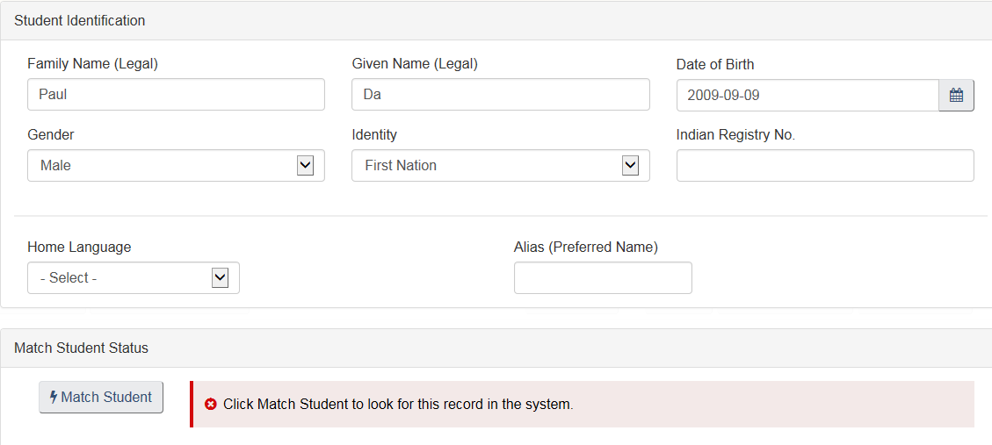

- A list of Potential Near Matches are displayed.
    - Search results display up to 10 potential matches
    - Results are ranked on how closely the records match the search criteria
    - Highest ranking records are presented first (e.g., a match on the IR No. is always first)
    - Ranking ‘weight’ is heavier on an exact match versus contains (e.g., if you enter a partial name such as ‘Da’ the system searches for every name with ‘Da’ such as Dan Davidson, Ardan, Candace, etc.)
    - If the search criteria is too wide then you will be presented with 10 potential near matches, but some will get ‘dropped’ off the list.
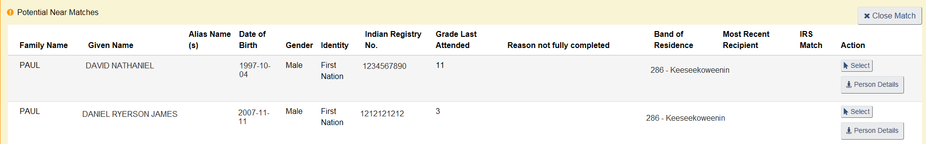

- Look at the list of Potential Near Matches to determine if there is an existing student record in the system for which this student can be ‘matched’.
    - The button provides additional details to help make a ‘match’ decision. Refer to the Person Details section on the next page for more details.
- If one of the students is a match, click on the button.
- Note: If the student is a brand new student there will be no match. Fill in all Student Identification information and Student Enrolment information. A warning will be displayed during validation in the Errors and Warnings report (i.e. ‘This student record was not found in the system. Verify and update if required. Otherwise, a new student record will be created’). This is to let you know that a new record will be created in the database for this new student.
- Click OK on the warning message to replace the Student Identification with the Potential match student information.
- Student is now matched in EIS and the student record is locked (i.e., it cannot be edited).

Clients Served
                - When a report has been rolled-over or uploaded into EIS, go to the Clients Served chevron for each Delivery Organization and view the Match Student Status column.
- On the Navigation Menu, navigate to a Delivery Organization.
- Select the Clients Served chevron and the list of students is displayed.
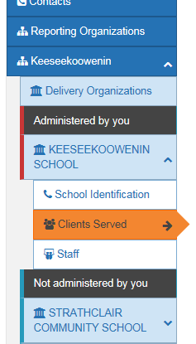
- Click on the button to perform an exact match on all students.

- Look at the Match Student Status column to view the ‘match status’ for the students.
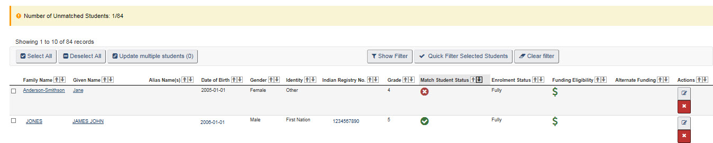
means that the student has been matched to the EIS or IRS database. No further action is required.
means that the student matching was not successful. Open the student information to see if the student can be matched to an existing record. Often it is a new student that has been added to the Report. Go to step 5 below.
means that an IRS look-up has resulted in a potential match for the non-IRS student.
Open the student information to see if the student can be matched to an existing record. Go to step 5 below.
- Click on the (Edit) button or on the student’s name (i.e., hyperlink) to view the student information.
- Click on the button to use the Match functionality to determine if there is a student record in the database that has similar student information.
- If a student in the list of Potential Near Matches is a match, click on the button and click OK on the warning message to replace the Student Identification with the Potential Near Match student information.
- If there are no matches (e.g., a brand new student) then verify that all the information is correct for the student and click the Close button. A warning will be displayed during validation on the Errors and Warnings report (i.e. ‘This student record was not found in the system. Verify and update if required. Otherwise, a new student record will be created’). This is to let you know that a new record will be created in the database for this new student. The ‘match status’ will change to after the next state change.

Person Details
                - The button is used to display additional information on student records that are already in EIS or IRS. The button can be found:
- When adding a new student, click on the button and a list of Potential Near Matches is displayed. The button is located in the Actions column.
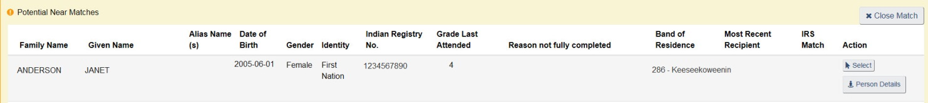

- When looking at the list of students (Clients Served), click on a student’s name or the (Edit) button in the Actions column. The button is located at the top in the toolbar.
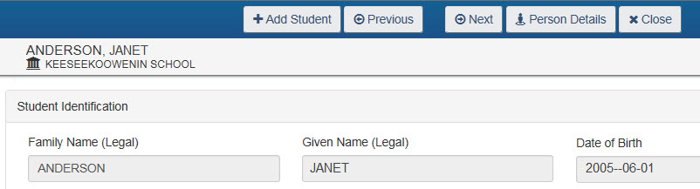
                - To view the additional information to help determine if a record is a match:
- Click on the button to be provided with additional information regarding a student.

- On the View Person Information window, click on the tabs along the bottom for more information relating to:
    - NR Historical Information
    - PSE Historical Information
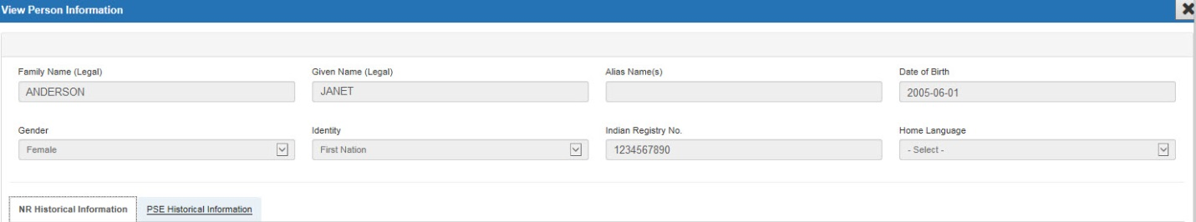
NR Historical Information
    - Lists the fiscal years that the student attended school, the name of the Delivery Organization (school), Grades, Enrolment Status, etc.
    - Previously found using the Student Historical Information button on a student record.

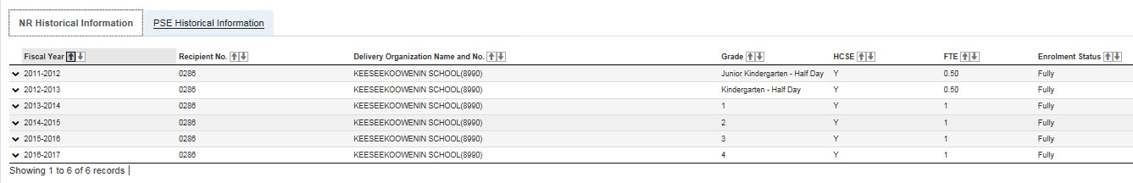
PSE Historical Information
    - Lists the fiscal years that the student attended a Post-Secondary institution, the Semester, the Institution Name, etc.

Search Using an Indian Registry Number (IR No.)
                - A quick way to look for a student is to use the IR No. For example, you are adding a student to the Nominal Roll and search for the student using the number only. It requires less typing and is accurate in finding an individual.
- Click on the button.
- Select First Nation from the Identify field drop-down list.
- Enter the IR No. only with no other data in other fields.
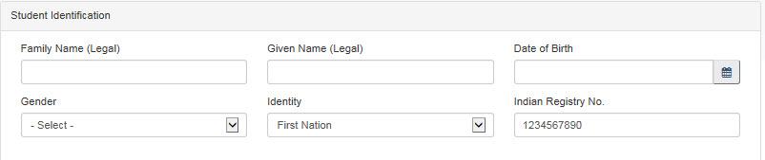
- Click on the button. The list of Potential Near Matches displays only one student with that IR No.
- Note: If the IR No. is entered along with other fields, the student who has that IR No. will be displayed at the top of the list followed by other potential matches.
Historical IR No.
If the tombstone data is an exact match (i.e., all Student Identification fields are provided) and the historical IRS number was used, then EIS will replace the old IRS No. with the current one, and the student will be matched.
A new message will be presented to alert you that the historical number has been replaced. A similar message will also be presented at validation and will be displayed in DQR.
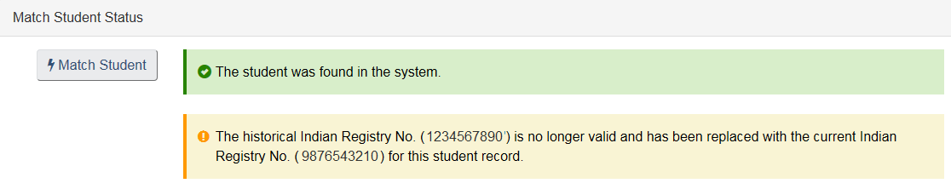

Indicators and Validations
IRS Match Indicator
                - The list of Potential Near Matches displays an indicator in the IRS Match column that acts as a ‘flag’.
- The IRS Match indicator ( ) informs you that the record retrieved from IRS matches the number that you entered when searching.

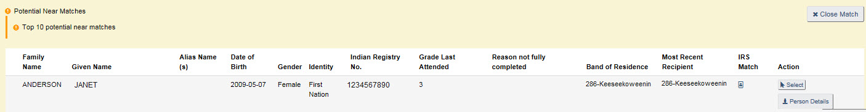

Resolve Student Merge
This feature is for Recipients and Regional users and is for a very specific situation. It is used to merge student records when a student is matched as an IRS student and EIS checks to see if a similar, unregistered student is on the previous year’s Nominal Roll.
Example: An IRS student record has been found and the system has retrieved a record for an unregistered (non-IRS) student that appears to be the same as the IRS student.
- Click on the Resolve Student Merge button to merge the student records.
The Resolve Student Merge screen displays the enrolment history for both the registered First Nation student and unregistered First Nation student.
- Review the historical information and choose to:
    - merge the enrolment information for the students (Merge Student Records) or
    - leave the historical information as two separate entities (Do NOT Merge Student Records)
- A decision must be made before the next status change or during Validation!

