SUGGESTIONS FOR CONTINUOUS LEARNING
DRAFT FOR FEEDBACK MARCH 27, 2020

Purpose
Recognizing that First Nations have authority for the education of their citizens, including having full responsibility for their own schools, how First Nations choose to address continued learning while their schools are closed will vary from community to community.

Within that context, this document is intended to provide suggestions that teachers and education leaders can adapt and share with their families and students through mechanisms that best suit their particular circumstances.

Background
This document is being shared to offer guidance to First Nation and First Nation school representatives as they consider how to promote continued learning opportunities for students while their classes are suspended.

FNESC and FNSA fully respect the authority of each First Nation to make decisions about the continued operations of their schools and staff during this time of change. We also recognize that community and school representatives best understand local needs, circumstances, and decisions, including varying levels of family access to resources, technology, and connectivity, and differing opportunities for community and school staff to provide learning materials to students and families who might be restricted to their homes.

FNESC and FNSA acknowledge that it is up to First Nations to determine:
- whether school staff should continue working while classes are suspended, and if so whether they should work in the school or from home;
- whether all school and community facilities should be closed, including outdoor parks and playgrounds;
- whether school staff should be phoning / emailing / texting students and families directly; and
- whether packages of learning materials can be safely provided to families and students.

All of those factors will impact on what remote learning activities are possible.

Therefore, these suggestions and ideas are being shared with educators and education leaders in First Nations schools to be adapted and used as appropriate to benefit students and families in varying contexts.

This document will be updated and periodically redistributed to reflect feedback from community and school representatives, and as new suggestions arise. We welcome ideas for other activities.

Additional information will also be provided as the response from the BC Ministry of Education is clarified, recognizing that the Ministry is also preparing suggestions for continuity of education while public and Independent schools are closed. For First Nations schools with Independent School status, additional information may be provided by the Independent Schools Branch. We encourage Independent Schools to monitor any Independent School-specific information and expectations, as well.

Considerations for the Suggested Continued Learning Opportunities

- First Nations leaders across the country have announced that their communities are in a state of emergency. In this situation, while remote learning activities can be valuable and beneficial for students and families, the health of First Nations citizens (both physical and mental) and community safety are the primary priorities.
- Many First Nations are requesting that only people in one household should be together. Any First Nation directives regarding self-isolation / possible lock-down procedures must be respected first and foremost.
- In these challenging times, it is particularly important to encourage parents, children and other family members in the same household to enjoy quality time together at home.
- Any recommended remote / home learning activities should not become a source of anxiety for students and families; student and family mental and emotional well-being cannot be compromised by introducing additional stress through overly prescriptive or unrealistic learning expectations.
- It is not feasible to replicate a school day while school is suspended and children cannot gather together with teachers and other school staff.
- Home learning activities must be reasonable; they should not require excessive time and resources that not all families will have available. Suggested activities should not encourage families to leave their homes to access supplies.
- Many home learning activities can meet the learning standards in the BC curriculum.
- Home learning activities should not require students / parents gathering with people from different households.
- All activities must be safe for everyone involved.
- Home learning activities will ideally be of interest to parents and students, and they should be enjoyable and hands-on as much as possible.
- Cultural activities and language learning opportunities can be an important part of suggested home learning activities.
- Technology equipment and internet access may be limited in some homes, and on-line options cannot be relied on as the only remote learning option. Teachers may be able to connect with families and students on-line, or by email, through Facebook or other social media, by telephone, or through text messaging in order to offer support and guidance.

Suggested Remote Learning Activities

The following are suggestions for engaging and easy to implement activities that educators can share with families and students. They are designed to support remote learning opportunities while schools are not in session.

The suggested activities are divided into three categories: K4 - grade 3; grades 4 – 7; grades 8 – 12 and adult learners. Where the activities are appropriate for varying grade levels, they are repeated in each category. Flexibility in interpreting the suggested grade levels is also entirely appropriate.

Along with a brief description of the suggested activities is a link to relevant web pages.

FNESC staff also are available to assist First Nations school educators and education leaders in discussing remote learning opportunities and how they connect to the curriculum, including helping with ideas that: are easy to implement; can be undertaken in a range of circumstances; and respect the importance of families supporting one another and enjoying time together, especially during stressful circumstances. Please feel free to contact FNESC staff by email or phone for further assistance.

K4 - GRADE 3

First Voices
With a kids’ section included on this web site, students and families can learn simple phrases and words for First Nations Languages in BC. https://www.firstvoices.com

Scavenger hunts
Scavenger hunts are a great way for families to spend some fun and active time together. They provide children with opportunities to increase their vocabulary and to categorize objects. This activity can be used indoors. If it is possible to go outdoors safely and at an appropriate distance from others, scavenger hunts provide an opportunity to share knowledge of the land around the home. More details are included in Appendix 1. Remember: any outside activities should be considered carefully with the safety and well-being of participants in mind, and recognizing any related First Nations’ directives related to social distancing.

CircleRound
This web site provides carefully selected folktales from around the world that have been adapted into sound and music-rich radio plays for kids. https://www.wbur.org/circleround

Podcasts
These science and technology related podcasts will ignite student curiousity and wonder about the world of science. Topics range from “The secret world of dust” to “Dreams: The science of a sleeping brain.”
Wow! In the world https://www.npr.org/podcasts/510321/wow-in-the-world
Brains On! https://www.brainson.org

Child-created / directed games
Child-created games allow for creativity and give children the ability to take the lead in play. Games can reinforce math concepts, as well as writing of letters, numbers and words. They encourage families to share and play with one another in the home. See Appendix 2 for more details.

Epic books
This resource is free for a month and contains thousands of fiction and nonfiction books and videos, as well as a section with books that are read aloud. https://www.getepic.com

Reading Eggs
This resource, available free for one-month, includes reading games for 2-4 year olds, 5-7 year olds, and 7-11 year olds. It teaches phonics in a fun, research-based way with repetition. It also builds comprehension, fluency, spelling, vocabulary, and writing skills. https://readingeggs.com

Chatterpix Kids!
This is a fun, free app that can be used for storytelling. Children can take a picture of any object and the app magically animates it with a talking mouth. Download the app on your phone or tablet.

www.ck12.org
This website is free and has lessons at all grade levels and in many subject areas. It includes videos, books, lessons, visuals, and resources. It also has simulations to help students learn math and science concepts with numerous options for practice.

Math card games
With just a deck of cards, students of all ages can use simple and fun card games to build skills ranging from simple addition and subtraction to fractions, decimals and exponents. https://mathgeekmama.com/best-math-card-games/

Fun science experiments for kids!
Any suggested activities should be considered with the items that families currently have in their homes. Families should not be encouraged to go and get materials from elsewhere.
https://www.youtube.com/watch?v=TD_p9-PCEk8 (slime)
https://www.youtube.com/watch?v=z-MsYagHs10 (kitchen science)
https://www.youtube.com/watch?v=5wLv3pCqZ9o (Ocean in a Bottle)

Kids Art Hub
This fun youtube video is aimed at young children who are interested in learning to draw. Any suggested activities should be considered with the items that families currently have in their homes.
https://www.youtube.com/watch?v=EZ2h6W4YVz0&t=403s

How to Grow a Garden from Kitchen Scraps
This short video shows kids how to take everyday vegetables, soak them, and wait for the roots to arrive. Any suggested activities should be considered with the items that families currently have in their homes. https://www.youtube.com/watch?v=n6QnKAyBKu4

Go Noodle
This fun, kid-friendly site includes tips and tricks to stay active and healthy. Activities range from physically active games to yoga, mindfulness activities, and confidence boosters. https://www.gonoodle.com

Geering Up Online
Every day, Geering Up brings a new STEM experiment and activity. This site breaks down the scientific concepts behind the activity, and offers suggestions for how to try the activity at home. Live-streams will bring interactive and exciting experiences for viewers of all grades! https://geeringuponline.apsc.ubc.ca/families/daily-activities/

Additional on-line resources for families
Fun experiments, fact pages, writing activities, and videos for science and social studies are available on these web sites. https://kids.nationalgeographic.com; http://www.pobble365.com; www.brainpop.com

Read Works
This web site is an excellent resource for reading and reading comprehension activities. If computers are not available for all students, all of the resources are printable. https://www.readworks.org

Khan Academy
This web site provides free, fun online learning classes (with assessments) for math, science, storytelling, computer programming, history, art, economics and much more! https://www.khanacademy.org

GRADES 4 - 7

First Voices
With a kids’ section included on this web site, students and families can learn simple phrases and words for First Nations Languages in BC. https://www.firstvoices.com

Scavenger hunts
Scavenger hunts are a great way for families to spend some fun and active time together. They provide children with opportunities to increase their vocabulary and to categorize objects. This activity can be used indoors. If it is possible to go outdoors safely and at an appropriate distance from others, scavenger hunts provide an opportunity to share knowledge of the land around the home. More details are included in Appendix 1. Remember: any outside activities should be considered carefully with the safety and well-being of participants in mind, and recognizing any related First Nations’ directives related to social distancing.

CircleRound
This web site provides carefully selected folktales from around the world that have been adapted into sound and music-rich radio plays for kids. https://www.wbur.org/circleround

Interview a community role model
This activity encourages children to explore the process of generating questions, interviewing, organizing information, and making a product. Participants should be sensitive to the individual needs and feelings of people to be interviewed and they should connect remotely. See Appendix 3 for more ideas.

Podcasts
These science and technology related podcasts will ignite student curiosity and wonder about the world of science. Topics range from “The secret world of dust” to “Dreams: The science of a sleeping brain.”
Wow! In the world https://www.npr.org/podcasts/510321/wow-in-the-world
Brains On! https://www.brainson.org

Outdoor walk
The purpose of this project is to bring children onto the land, have them ask questions, make observations, and encourage everyone to share their knowledge about the territory. Tips are included in Appendix 4. Remember: any outside activities should be considered carefully with the safety and well-being of participants in mind, and recognizing any related First Nations’ directives.

Epic books
This resource is free for a month and contains thousands of fiction and nonfiction books and videos, as well as a section with books that are read aloud. https://www.getepic.com

Make a Plant Collection
Keeping a plant collection and thinking carefully about the kinds of plants that are growing around the community is a good learning activity. Appendix 7 shares further ideas for this activity. Remember: Any suggested activities should be considered with the items that families currently have in their homes. All outside activities should be considered carefully with the safety and well-being of participants in mind.

Activities that appreciate family connections
Many activities can make time with families extra-special, as family connections are a meaningful source of learning for students of all ages. Appendix 5 includes several suggested activities, and students can be encouraged to present their learning through photos, artifacts, story-telling, interviews, writing and drawing.

www.ck12.org
This website is free and has lessons at all grade levels and in many subject areas. It includes videos, books, lessons, visuals, and resources. It also has simulations to help students learn math and science concepts with numerous options for practice.

Additional on-line resources for families
Fun experiments, fact pages, writing activities, and videos for science and social studies are available on these web sites. https://kids.nationalgeographic.com; http://www.pobble365.com; www.brainpop.com

Paper Airplane Science
Students can test their airplane making skills and record how well each design performs, considering airplane composition – as described in Appendix 6.

Read Works
This web site is an excellent resource for reading and reading comprehension activities. If computers are not available for all students, all of the resources are printable. https://www.readworks.org

You Be the Critic
Students can critique something familiar, using evidence to evaluate and rank options, and then produce a video (or other product) explaining their rankings. This would be a great activity for friends to share with each other, and/or with a teacher. Two options for this activity are included in Appendix 8 You Be the Critic: Video Game Edition; and You Be the Critic: Snack Edition. Other topics can be substituted for this activity. Appendix 8 suggests writing a script and recording a video to describe the findings. Other options, such as writing a critique or presenting the findings to other family members live, can be suggested.

Activities for families
Any suggested activities should be considered with the items that families currently have in their homes. All outside activities should be considered carefully with the safety and well-being of participants in mind, and recognizing any related First Nations’ directives.
- Texture Walk - Create a list of words to describe how things feel to the touch. Go for a walk and see how many things you can find that match the describing words.
- Relax and Listen - Go outside and sit or lay down and remain quiet for a few minutes. Relax and listen to the sounds you hear. Imagine a story to go along with the sounds. Write, draw, or tell your story to your family.
- Obstacle Course - Design an obstacle course for the whole family. Think of different ways to go through the course each time – such as hopping, walking backwards, etc.

Khan Academy
This web site provides free, fun online learning classes (with assessments) for math, science, storytelling, computer programming, history, art, economics and much more! https://www.khanacademy.org

GRADES 8 - 12 AND ADULT LEARNERS

First Voices
Students and families can learn simple phrases and words for First Nations Languages in BC. https://www.firstvoices.com

Read Works
This web site is an excellent resource for reading and reading comprehension activities. If computers are not available for all students, all of the resources are printable. https://www.readworks.org

Khan Academy
This web site provides free, fun online learning classes (with assessments) for math, science, storytelling, computer programming, history, art, economics and much more! https://www.khanacademy.org

www.ck12.org
This website is free and has lessons at all grade levels and in many subject areas. It includes videos, books, lessons, visuals, and resources. It also has simulations to help students learn math and science concepts with numerous options for practice.

Make a Plant Collection
Keeping a plant collection and thinking carefully about the kinds of plants that are growing around the community is a good learning activity. Appendix 7 shares further ideas for this activity. Remember: Any suggested activities should be considered with the items that families currently have in their homes. All outside activities should be considered carefully with the safety and well-being of participants in mind.

Activities that appreciate family connections
Many activities can make time with families extra-special, as family connections are a meaningful source of learning for students of all ages. Appendix 5 includes several suggested activities, and students can be encouraged to present their learning through photos, artifacts, story-telling, interviews, writing and drawing.

Podcasts
These science and technology related podcasts will ignite student curiosity and wonder about the world of science. Topics range from “The secret world of dust” to “Dreams: The science of a sleeping brain.”
Wow! In the world https://www.npr.org/podcasts/510321/wow-in-the-world
Brains On! https://www.brainson.org

Additional on-line resources for families
Fun experiments, fact pages, writing activities, and videos for science and social studies are available on these web sites. https://kids.nationalgeographic.com; http://www.pobble365.com; www.brainpop.com

www.ck12.org
This free website has lessons for all grades and in many subject areas. It includes videos, books, lessons, visuals, and resources. It also has simulations to help students learn math and science concepts! Lots of options and practice are available.

You Be the Critic
Students can critique something familiar, using evidence to evaluate and rank options, and then produce a video (or other product) explaining their rankings. This would be a great activity for friends to share with each other, and/or with a teacher. Two options for this activity are included in Appendix 8 You Be the Critic: Video Game Edition; and You Be the Critic: Snack Edition. Other topics can be substituted for this activity. Appendix 8 also suggests writing a script and recording a video to describe the findings. Other options, such as writing a critique or presenting the findings to other family members live, can be suggested.

Paper Airplane Science (grade 8 – 12)
Students can test their airplane making skills and record how well each design performs, considering airplane composition – as described in Appendix 6.

Appendix 1
Scavenger Hunt

Any outside activities should be considered carefully with the safety and well-being of participants in mind, and recognizing any related First Nations’ directives about staying at home.

Create a scavenger hunt together! Be sure to consider if you will be able to maintain social distancing if you choose to leave the house.

Here are some pre-made scavenger hunts and tips for making a scavenger hunt:

myopencountry.com https://www.myopencountry.com/nature-scavenger-hunt/
lovetheoutdoors.com http://www.lovetheoutdoors.com/camping/kids/scavengerhunt.htm
CBC Parents https://www.cbc.ca/parents/search/results/?q=scavenger+hunt

Feel free to customize lists to fit your community, and be creative

Materials:
- scavenger hunt list / grid / chart
- pen / pencil / marker

Suggestions

Pre-readers – An adult reads each item for the child; the child draws the item when found
– Items are listed using pictures; the child colours each picture found

Readers / writers – Items are listed using text; the child adds…
- two words describing the item (eg. how it feels, smells, looks, etc.)
- specific species names (eg. fir for “tree”) and ideally the item name in their traditional language (https://www.firstvoices.com/)

Here are two samples:

Around the House In Nature

Item | Picture/Description |  | Item | Picture/Description
Drum |  |  | Bird nest
A piece of art |  |  | Berry bush
Traditional food |  |  | Flower
Feather |  |  | A cool rock
Board game |  |  | A big tree

Appendix 2
Child Created / Directed Game
(“Super Bounce” Game by Mo Willems)

Resource:
Lunch Doodles with Mo Willems https://youtu.be/K5guOVOuVMs

Materials:
- large sheet of paper /drawing surface (eg. the inside of a flattened cereal box, butcher paper, large paper bag, …)
- marker, crayon, etc.
- dice or coin
- game “piece” or marker (this can be anything at all!)

Directions:
- Draw you own gameboard (be creative, make it your own!). See photos below for examples.
- Make up the rules. Eg. roll the die to move, or flip a coin: heads move ahead 2 spaces; tails 3 spaces. If you land on a space already occupied by another player, you bounce forward 1 space, they bounce backward 1 space.
- Move your game piece – the first to reach the end wins!

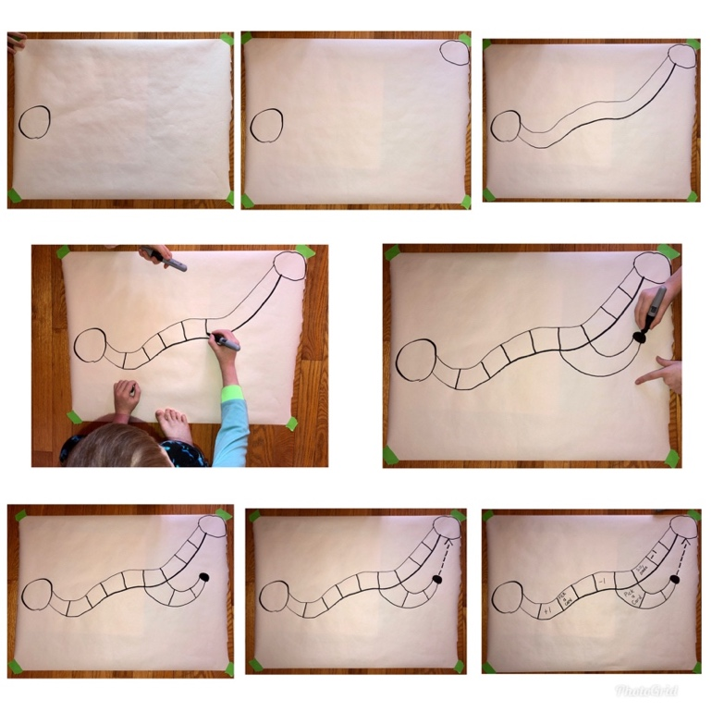

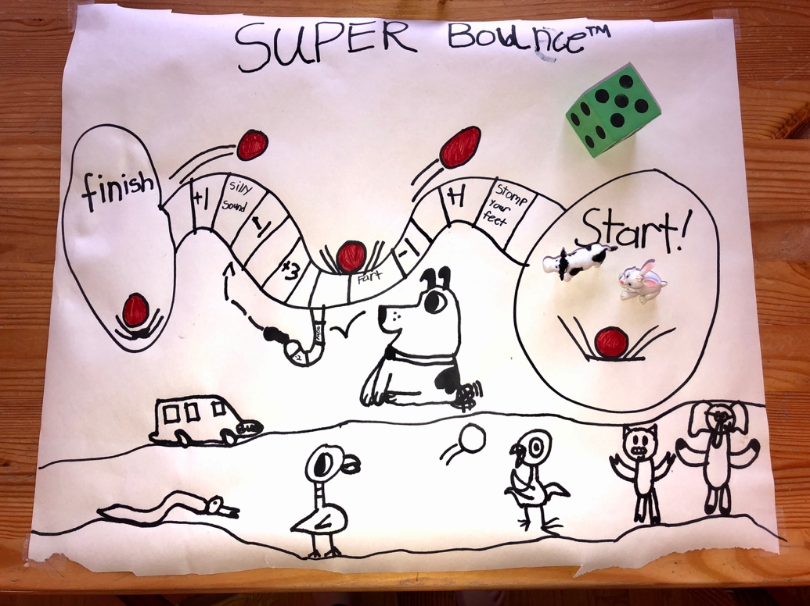

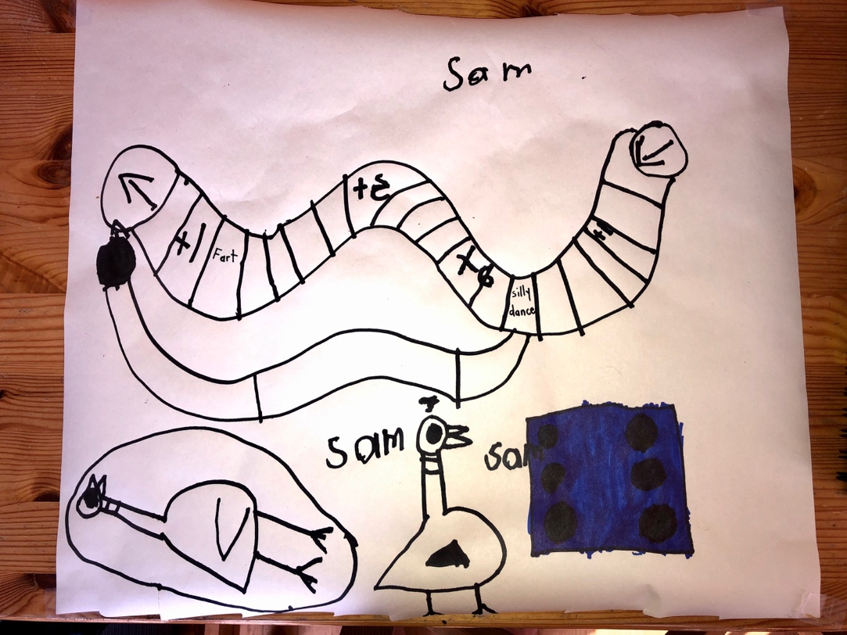

Appendix 3
Interview With a Community Role Model

Connect with a member of the community who you admire (family member, Elder, friend … anyone who is important to you) and interview them. Then decide how to share your interview with others.

Step 1: Do your research. Listen to other interviews (on TV, Podcasts, Youtube) to determine the kinds of questions you might want to ask!

Step 2: Choose a person you would like to interview and arrange a time. Tip: Ask your interviewee what time works best for them or suggest 2 or 3 possible times. You may also want to provide them with the questions ahead of time.

Step 3: Generate a list of 5 to 10 questions. (Feel free to use questions you have heard in other interviews.). Examples of possible interview questions:
- What is your favourite memory from your childhood?
- What was your favourite music/art as a kid? What made you choose that?
- What was your favourite childhood story? Will you tell me that story? May I share that story?
- What is your favourite sport to play or watch? Do you think it is important for young people to play sports?

You may also want to generate questions specific to their role in the community.

Use this link if you want ideas for generating your own questions: https://docs.google.com/file/d/0B7x_ZBobTEDja0RyQWJ4LUpyajg/edit

Step 4: Conduct the interview. Please do so in a safe way! Speaking over the phone or through video would be best, unless the person lives with you.

Tip: Journalists usually record interviews and take notes. If you want to record the interview, ask permission first. If you are taking notes, don’t hesitate to ask your interviewee to repeat something or pause while you make notes. Parents can help children take notes, too.

Step 5: Determine how you will share your interview with friends and family
- Share a video of the interview (ONLY if you have permission to do so) (eg. https://www.youtube.com/watch?v=WAqxc5CALcc)
- Write a newspaper-style article (eg. https://nowtoronto.com/music/features/snotty-nose-rez-kids-interview/)
- Create a video using information from your interview showcasing the person you spoke with (ONLY if you have permission to do so) (eg. https://www.youtube.com/watch?v=g6czQR2RUao)

Appendix 4
Outdoor Walk (forest or shore of the ocean, a river, or a lake)

Any outside activities should be considered carefully with the safety and well-being of participants in mind, and recognizing any related First Nations’ directives about staying at home.

The purpose of this activity is to notice things that haven’t caught your attention before, to ask questions about them, and to share your observations. Below are some examples to get started, but open yourself up to observe and notice other parts of nature specific to your community.

Please remember to maintain social distancing when you are out of your house.

Materials:
- Notebook
- Pencil / pencil crayons / markers etc.
- A sense of adventure
- Camera or smartphone to take pictures (if available)

Forest:
Notice the mosses.
- How many different kinds of moss can you find?
- Draw each one
- Talk about what is different
- What are two questions you have about the mosses?

Notice the branches on the trees and the kinds of needles on them.
- How many different kinds of branches with needles can you find?
- Draw each one
- Talk about what is different about them
- What are two questions you have about the branches and their needles?

Notice the creek that runs through the forest.
- List three things you notice about the creek
- What are you curious about? List as many questions about the creek as you can
- Share your observations and questions with an adult

Shore:
Notice what makes up the shore. Sand? Rocks? Driftwood? Plants?
- What do you notice about the sand or pebbles etc.?. ... Draw what you notice
- Write two questions you have about the sand or pebbles etc.

Notice the Rocks on the shore.
- How many different kinds of rocks can you find? How might you categorize them? Large or small? Smooth or rough? Dark or light?
- Draw one rock from each category
- List one similarity and one difference
- What are two question you have about the rocks?

Notice the driftwood on the shore.
  - What are 3 things you notice about the driftwood?
  - Draw your favourite piece of driftwood
  - What does the driftwood remind you of? (tell someone)
  - What are two questions you have about the driftwood?
  - Tell an adult (parent / teacher / EA) about your observations and questions

Notice the plants on the shore.
  - What do you notice?
  - What questions do you have about the plants?
  - Where else have you seen these plants?

Other possible activities:

- Students can harvest traditional medicine, if appropriate, and learn how to properly and respectfully prepare it. Where possible, students could discuss the benefits of different types of medicines.

- If it is appropriate, students might reach out to an Elder of community member to learn about how to harvest medicinal plants and where they are located.

- Students can gather medicines for Elders who are not as mobile, if it can be done safely and delivered later at a time when it is safe to do so.

Appendix 5
Activities That Appreciate Family

Families are important for developing a sense of self and a connection to place. Think about your family and their importance to you.

During this time, you may be spending a lot of time with family. This project will help you better get to know your family and your family history. You may also be able to create some fun activities and use positive connections with one another to help your family in this uncertain time.

Below are a few activities you might consider. Choose 2 or 3 (or maybe all of them!) and keep a daily journal about your experiences and your thoughts about how connecting with family makes you feel.

- Create a graphic organizer that represents your connections with your family. It could be a chart, a mind map, something else … be creative. You may also want to include your thinking about what families do: they live together, work together, sing together, love each other, celebrate together …

- Prepare foods together. You could call a family member who cooks food you love, and – if the ingredients are handy at home – prepare a recipe with them over the phone or using video chat. You may want to:
- video tape your preparations like you’re on a cooking channel
- create “new recipes” based on what is in the fridge
- try the 100 Mile Diet – only using ingredients harvested within 100 kms
- create new ways to eat fry bread/bannock
- share a meal with the people who live in your household

- Plan a “virtual dinner party.” Send other family members a menu for the night, including recipes if needed. Everyone will prepare the meal in their own homes. Choose an easy meal with ingredients everyone likely has at hand, like spaghetti.
  - Set up a device to allow everyone to be seen and heard on a video call.
  - Prepare some questions or conversation topics ahead:
    - Name one thing you are grateful for
    - What’s a favourite memory about someone at the party?
    - What’s something new I have learned this week?
    - What’s something you are looking forward to?

- Make a “Family Trivia Game.” This is a good activity for learning more about your family history because you can draw on many relatives’ memories and experiences. Brainstorm trivia questions that involve your family. What village did grandma come from? What is auntie’s traditional name? Who is a better hunter – grandpa or uncle? Be creative and have fun! You can also involve people who live in other households if you can connect with them by phone or video chat.

Appendix 6
Paper Airplane Science

Step 1: Design and construct 2 paper airplanes. Be creative!

Step 2: Predict which plane will fly farther.

 | Plane A | Plane B
List three different design features of each airplane
Which airplane is more likely to fly farther and why?

Step 3: Design your experiment

- Choose and mark your launching point

- Determine how you will measure the flight path (it needs to be something you can keep consistent, such as the length of your foot, a measuring tape, a book-length, etc.)

- Determine how many times you will launch each plane (we recommend at least 5)

- Create a table to record your data (below is a sample)

 | Trial 1 | Trial 2 | Trial 3 | Trial 4 | Trial 5
Plane A
Plane B

- Determine which plane flew farther in each trial. If you want to challenge yourself, determine the average distance each plane flew (total the distances of each trial and divide by the number of trials).
- Why do you think one plane flew farther than the other plane?

- Determine how to share your results
- Create a video or a photo journal that shares your results
- Draw a sketch of the planes that includes a description of the features
- Write a report on your results (include your prediction, observations and conclusion)

- Using what you learned, build new planes that you predict will fly farther and repeat the steps!

Appendix 7
Make a Plant Collection

This activity should be considered with the items that families can gather safely. All outside activities should be considered carefully with the safety and well-being of participants in mind.

Step 1: Find 20 different plants. Take a clipping, or dig up the whole plant and wash/dry the roots.

Step 2: Press the plant between pieces of paper or cardboard. Fold the plant if necessary, but don’t break it. Put weights on top of it.

Step 3: A few days later when the plant is dry, tape each plant on a page to make a booklet. If the plant is too big, tape sections on the page instead.

Step 4: On each page write the date, time, and location you found the plant, its name, what you know about it, and, if possible, its name in your First Nations language. Template below

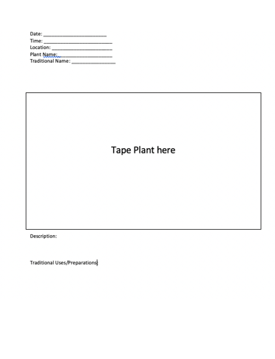

Step 5: Reflect on the plants you have chosen, considering:
- The importance of the plant to your community and family
- The historical importance of the plant
- How climate change may impact the plant species you have chosen
- Which species are introduced or invasive

Step 6: Choose a medium to share your new learning. Here are some examples:
- Make a TikTok
- Write a poem
- Create a PowerPoint
- Create a local field guide
- Write a news article

Appendix 8
You Be the Critic:
Video Game Edition

Step 1: Choose 2 video games

Step 2 : Give each game a rating in each of the categories

- Top Rating
- Lowest Ranking

Game | A. | B.
Graphics
Sound Quality
Music
Storyline
Fun Factor
Playability
Total Controllers

Step 3: Determine the overall game ranking by totaling the columns

1)
2)

Step 4: Write a script for a video describing the game ranked #1. Include evidence related to each of the categories you used to rank the game (graphics, sound quality, music, storyline, fun factor, and playability).

Step 5: Record the video

Step 6: Share the video with your friends and family

You Be the Critic:
Snack Edition

Step 1: Choose 5 Snacks

Step 2 : Give each snack a rating in each of the categories

Top Rating
Lowest Rating

Type of Snack
Flavour
Crunch-ability
Smell
Appearance
Fullness Factor
Share-ability
Total Yums

Step 3: Determine the overall snack ranking

1)
2)
3)
4)
5)

Step 4: Write a script for a video describing the snack ranked #1. Include evidence related to each of the categories you used to rank the snack (flavor, crunch-ability, smell, appearance, fullness factor, share-ability).

Step 5: Record the video

Step 6: Share the video with your friends and family

