SUGGESTIONS FOR FAMILIES:
SUPPORTING LEARNING
AT HOME

Prepared by the
First Nations Education Steering Committee
And
First Nations Schools Association

Introduction

The First Nations Education Steering Committee (FNESC) and First Nations Schools Association (FNSA) appreciate that this is a time of great change. As in-person classes are not taking place, First Nations throughout the province are deciding how to support continued learning.

- FNESC and FNSA respect that First Nations have authority for the education of their citizens.
- First Nations are responsible for making decisions about their own schools. It is expected that First Nations schools will be providing varying types of learning opportunities while in-person classes are suspended, reflecting what is possible and best for families in each community.
- The Ministry of Education has also communicated that public schools can use different approaches to help students learn while classes are not taking place in the school building.
- This means that children’s learning activities may be in different forms depending on where they regularly attend school, but all learning will look very different from the conventional school day.
- In this situation, most student learning will be taking place in their homes.

Families are always their children’s first and most important teachers, and your role in your children’s education is going to be especially critical in the weeks ahead.

FNESC and FNSA prepared this paper to share suggestions to help you provide important learning opportunities for your children.

We encourage you to use any of the ideas that are right for you, or to adapt the ideas to make them suitable for your children and your home environment.

We also hope that you can work with your children’s teachers and schools to identify how your valuable contributions can complement the learning activities they are recommending.

Thank you for everything you do. We know that the time your family is spending together now can have meaningful impacts for years to come.

Background

FNESC and FNSA know that First Nations best understand local needs and what resources are available to support learning opportunities in the home.

Each First Nations has the right and is best able to determine:
- whether and how school staff will continue working while classes are suspended;
- whether all school and community facilities should be closed;
- how school staff and families can effectively communicate with each other; and
- whether packages of learning materials can be safely provided to families and students.

Those decisions will impact on what remote learning approaches are used.

Given this complexity, suggestions are being shared for families, working with schools and teachers, to adapt and use as appropriate. All students, families, and homes are different. That means a range of ideas are needed to meet varying needs and situations.

This document will be updated as new suggestions arise. We welcome your ideas and feedback, as well as requests for additional types of supports that can help.

Considerations for Suggested Home Learning Activities

- First Nations leaders across the country have announced that their communities are in a state of emergency. In this situation, we know that the health of First Nations citizens and community safety are the primary priorities.
- Many First Nations are requesting that only people in one household should be together. Your Nation’s recommendations about physical distancing / possible lock-downs are the most important factor now. Do not feel that you need to leave your homes to access materials for home learning activities.
- In these challenging times, it is most important for families to enjoy quality time together at home.
- Any home learning activities should not be a source of anxiety for you or your children. Do not expect too much of yourselves, and keep home learning activities manageable and as enjoyable as possible.
- Remember that cultural activities and language learning opportunities can be a key part of your home learning focus.
- If you have access to technology and the internet, great. There are many fun and educational projects your children can access online. But you do not need to rely on the computer for learning options. There are many things you and your children can do off-line that are meaningful for their growth and development.

Some of the suggestions included in this document were adapted from the BC Ministry of Education resource: https://www.openschool.bc.ca/keeplearning/. Please visit that web site for additional ideas.
Suggested Home Learning Activities

Everyday Learning Activities

Learning is not limited to lessons, school work and textbooks. Children learn in very important ways in their daily routines and through the things they do each day.

Activities That Help Children Develop Their Communication Skills and Responsibility

- If possible, your children can connect with other family members, friends, Elders, and maybe their teachers by phone or using other technology. This can help children build their informal conversation skills and also develop their awareness of others.

- Review hand-washing, teeth brushing, and other practices to help your children think about self-care.

- Routines give children a sense of security and control over their environment. Establishing and following routines teaches young children self-control, positive behaviour, and social skills. Help your children to establish daily routines and a weekly schedule. Help them think about questions such as:
- When do I have the most energy to complete work that I find difficult? When is it easiest for me to concentrate and get work done?
- How often do I need to take a break and move my body?
- When should I take time for fun activities?
- What are some skills I really want to learn, but have never had the time to practice before?

- Ask your children to help with home chores and yard-work.

Activities That Help Children Develop Their Literacy / Reading and Writing Skills

- Read to your children, or have your children read to you. Together you can read labels on household items, recipes, directions for a craft or game, etc. Opportunities to read are all around you.

- Ask your children to read aloud to members of the family each day. They can read a story, a chapter of a book, an email from another family member, a newsletter … reading anything is beneficial.

- Older children could take turns reading and listening to their siblings. Some children enjoy reading to the family pet, or maybe to a stuffed animal toy. Children can read to someone over the phone.

- Ask your children to tell you about what they are reading or something they have read before. If you are reading something interesting, tell your children about it.
- Listening to your children talk about what they are reading can help you “check for understanding.” Knowing that children are understanding what they read, not just sounding out the words, is an important part of the learning process.
- By talking to your children about what you are reading, you are being an excellent role model and showing your children that you think reading is important in your life.

- Ask your children to draw (for younger children) or write (for older children) a summary or a review of a picture book, a novel, a game, a movie or TV show – anything will do. Then ask them to describe their drawing or read their review out loud to the family.

- Storytelling is an excellent way for children to learn and develop key skills. You can tell your children a story, or ask them to tell you a story they know. Maybe your children can call another family member on the phone to share a story.
- Sharing stories that are important for your culture and heritage is invaluable for many reasons.
- Younger children can tell stories about what they did that day.
- Older children can make up stories about imaginary characters.
- Families can build stories together by everyone taking turns adding ideas.

- Many teachers write daily notes to students. Your children can keep up this routine and write daily notes to siblings, friends, or family. The notes might include what they plan to do that day.

- Your family could make a “Stay Home” book, with each person contributing whatever is right for them – drawings, writing, photos, etc.

Activities That Help Children Develop Their Numeracy / Math Skills

- Playing cards or board games helps children practice math skills.

- Everyday life offers many opportunities to count, estimate, and measure. Just a few …
- How many spoonfuls of rice do we need to fill up our measuring cup? (Children can predict and then count to find the real answer)
- We made two dozen cookies. How many days will they last if we have six family members and we each eat one cookie every day?
- This recipe calls for ½ tsp salt. I am tripling the recipe. How much salt do we add?
- There are eight of us having lunch. How can I cut this pizza so we all get a piece the same size?

Activities That Help Children Develop Their Thinking Skills

- Learning something new is a great way to “build your brain.” What new skills can your children learn while they are at home: sewing, knitting, cooking, baking, woodwork, a new game, new words and phrases in their language, dance steps, etc.?

- Arts and crafts are creative and important thinking activities: beading, colouring, drawing, painting, sculpting, carving are all valuable.

- You can encourage your children to make music.
- Sing, alone or together (either together in person or using technology)
- Drum or play a musical instrument (alone, with others, or for others are all great)
- Set up an online performance, with everyone playing their part and using technology to connect with each other.
- Watch a free concert online, and talk together about what you thought of the performance.

- Just talking together is invaluable for helping your children with their thinking and for connecting together in positive ways. Having discussions with your children about every day topics helps with their learning more than you might think.
- For First Nations children, oral language development is a part of their cultures.
- Talking allows children to think, learn and make sense of their world.
- Conversations between adults and children boosts children’s brain response to language. It also helps strengthen the bond between family members.
- Conversations also help adults learn more about how children think about things.

What can you talk about?
- What is your child’s favourite toy or game? Why?
- What is their favourite book? What is their favourite part?
- What school subjects do they like? What don’t they like as much? Why?
- How do your children feel about not going to school every day? Is there anything they miss?
- What things in your community are most special?
- Do they miss their friends? What are they most looking forward to when school opens up again.
- What ideas do your children have for making this time with family at home more fun? What would they like to do together?
- Anything else that interests you and your children. Just talk and enjoy each other!

- If current conditions in your community allow it, spending time together out on the land or on the water can have many, many benefits for you and your children.
- You can talk about what you and your children know about your territory, your culture, and the importance of your heritage.
- Connections to the land and water are beneficial for everyone’s well-being and can really help to reduce stress and anxiety – for people of all ages!
- The fresh air and exercise are important for your health, too.

Learning Activities on the Internet

If you and your children have access to online learning tools, here are a few websites to consider.

Keeping Kids Active During the Pandemic
The First Nations Health Authority has created a list of fun activities to keep young children active and engaged while at home. https://www.fnha.ca/WhatWeDoSite/CommunicableDiseaseControlSite/PublishingImages/what-we-do/communicable-disease-control/coronavirus/public/keeping-kids-active-during-the-pandemic.pdf?fbclid=IwAR3n9k_wuxGo7s9U_9Lx6coAhgzCFdtJn53tLCwPhURyIiolVeCVK0gvSQE

First Voices
With a kids’ section included on this web site, students and families can learn simple phrases and words for First Nations Languages in BC. https://www.firstvoices.com

Chatterpix Kids!
This is a fun, free app for younger children that can be used for storytelling. Children can take a picture of any object and the app magically animates it with a talking mouth. Download the app on your phone or tablet.

CircleRound
This web site provides carefully selected folktales from around the world that have been adapted into sound and music-rich radio plays. https://www.wbur.org/circleround

Podcasts
These science and technology related podcasts will ignite student curiousity and wonder about the world of science. Topics range from “The secret world of dust” to “Dreams: The science of a sleeping brain.”
Wow! In the world https://www.npr.org/podcasts/510321/wow-in-the-world
Brains On! https://www.brainson.org

Epic books
This resource is free for a month and contains thousands of fiction and nonfiction books and videos, as well as a section with books that are read aloud. https://www.getepic.com

Reading Eggs
This resource, available free for one-month, includes reading games for 2-4 year olds, 5-7 year olds, and 7-11 year olds. https://readingeggs.com

Math card games
With just a deck of cards, students of many ages can use simple and fun card games to build skills ranging from simple addition and subtraction to fractions, decimals and exponents. https://mathgeekmama.com/best-math-card-games/

Go Noodle
This fun, kid-friendly site includes tips and tricks to stay active and healthy. https://www.gonoodle.com

Geering Up Online
Every day, the Geering Up web site includes a new science experiment and activity. This site breaks down the scientific concepts behind the activity, and offers suggestions for how to try the activity at home. The activities are meant for children of all grade levels. https://geeringuponline.apsc.ubc.ca/families/daily-activities/

Additional on-line resources for families
Fun experiments, fact pages, writing activities, and videos for science and social studies are available on these web sites. https://kids.nationalgeographic.com; http://www.pobble365.com; www.brainpop.com

Read Works
This web site is an excellent resource for reading activities. https://www.readworks.org

Khan Academy
Khan Academy provides free, fun online learning classes (with assessments) for math, science, storytelling, computer programming, history, art, economics and much more! It is great for learners of all ages – even adults! https://www.khanacademy.org

Remote Ready Science and Technology Challenges
This web site includes a wide selection of fun and educational challenges for students of all ages.
http://pblproject.com/page.aspx?pageid=Remote-Learning_STEM-Challenges

ProCon
For older children, the award winning ProCon.org website promotes critical thinking, education, and informed citizenship by presenting controversial issues in a straightforward, pro / con format.

IXL
If you have access to an internet connection, this site offers skill practice in all areas of math and at all grade levels. Parents can sign up for a free 30 day membership. www.ca.ixl.com

https://stories.audible.com/start-listen
Audible stories keep children engaged and learning by listening. This is a good activity to use along with crafting or creating art. Great for students of all ages – including adults.

Junior Achievement BC
JABC is a non-profit that delivers business education programs in schools across the province. Their web site includes activities that focus on financial literacy, work readiness and entrepreneurship for grades 4 – 12. https://jabc.ca/online-learning/

https://storylineonline.net
Watch and listen to read-aloud stories on this engaging and entertaining web site. Some books have activity guides for parents and teachers. Good for grades K- 4.

PBS Learning
PBS offers free educational videos, interactives, lesson plans, and more. You can create your own lessons, quizzes and activities with any of the resources. Good for learners of all ages. https://www.pbslearningmedia.org

www.virtualmuseum.ca
This site offers virtual tours and an online experience for exploring historic and cultural heritage sites, as well as exhibits. This is a good site for grade 4- 12 students and adults.

Additional Learning Activities That Don’t Require the Internet

The following pages include ideas for home based learning activities that we hope all families can enjoy.

Activity 1
Reading Books With Young Children

- Reading improves concentration and memory.

- Reading books allows children to learn about the world beyond their personal experience.

- Reading also boosts critical thinking skills and helps children develop empathy when they can relate to the characters in a book.

Tips

- When reading a book to your child, point out the title, and talk about what are pictures and what are words.
- Use your finger to read the story, showing that people read from right to left.
- If there are words that your children don’t know, explain what the word means or point to a picture that is related to the word.
- If the book includes feeling words (mad, sad, happy, scared), use facial expressions to show the feeling and have your children make the faces, too.
- If there is a problem to be solved, tell your children that it’s a problem, and ask them to think of a possible solution.
- If you’re reading a picture book, name and point to the pictures. Have your children repeat the words.
- At the end of the story, ask your children to retell what happened in the story.

Re-reading books is great, too. Repetition is great for practice !

Activity 2
Hungry Bear Game

The purpose of this activity is to have children repeat words, letter sounds, colours, shapes, numbers or to count the fish and feed the Hungry Bear. You can decide the focus.

Steps:

- Cut out the bear and fish (see next page).
- When you have chosen a focus, write something relevant on the back of the fish. For example, if you want your child to practice letter names, write the alphabet on the back of the fish. If you want to practice counting, write numbers on the back. Etc.
- Cut out the mouth of the bear
- Model or explain how to use the materials: say out loud what is on the back of the fish and feed the fish to the bear.

Other ideas to add:
- Read Brown Bear Brown Bear together. Have your children look around your home and tell what they see.
- Play hide and seek with the fish. Children can count how many fish they find. If more than one child is playing, the children can line up their fish on a surface and count the fish each person found.
- Play hot and cold using the bear. When your children get close to the bear, say “hot.” As your children get far from bear, say “cold.” Let your children find the bear.
- Read Going on a Bear Hunt. Hide the bear in one room in the house. Assign a sound to each room, such as kitchen – munch, munch munch; bedroom – shh, shh, shh; living room – blah, blah, blah; bedroom – tip toe, tip toe, tip toe, etc. Move from room to room having fun with the sounds and looking for the bear.

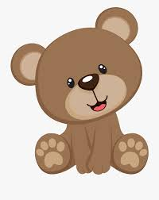

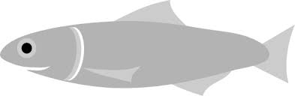

Activity 3
Shape Hunt

The purpose of this activity is for young children to notice shapes inside their home. Your children can walk through each room and mark down how many circles, squares, rectangles and triangles they see. Using the graph on the next page, your children can colour in the boxes.

Materials
- Shapes graph
- Crayons and pencil

Room 1 (circle or write the number of shapes in the space provided)
- Door 1 2 3 4 5 ________
- Windows 1 2 3 4 5 ________
- Decorations on wall 1 2 3 4 5 ________
- Stairs / floor 1 2 3 4 5 ________

Room 2
- Door 1 2 3 4 5 ________
- Windows 1 2 3 4 5 ________
- Decorations on wall 1 2 3 4 5 ________
- Floor 1 2 3 4 5 ________

Room 3
- Door 1 2 3 4 5 ________
- Mirror 1 2 3 4 5 ________
- Walls 1 2 3 4 5 ________
- Floor 1 2 3 4 5 ________

Room 4.
- Doors 1 2 3 4 5 ________
- Windows 1 2 3 4 5 ________
- Walls 1 2 3 4 5 ________
- Floor 1 2 3 4 5 ________

Colour in the squares to graph the number of shapes you found.

Circle | Square | Rectangle | Triangle

Draw pictures of the shapes you found

Room 1 | Room 2
Room 3 | Room 4

Answer the following questions

How many circles were: small _____ large _____

How many squares were: small _____ large _____

How many rectangles were: small _____ large _____

How many triangles were: small _____ large _____

Which shape did we find the most?

Which shape did we find the least?

Which room had the most shapes?

Why do you think there were more shapes in that room?

Other possible activities:

- Look in other rooms in the home
- Look for shapes in the yard
- Go for a walk and look for shapes

Activity 4
Scavenger Hunt

Any outside activities should be considered carefully with safety and well-being in mind,
and depending on whether your Nation has asked people to stay at home.

Create a scavenger hunt together! Be sure to consider if you will be able to maintain social distancing if you choose to leave the house.

You can find some pre-made scavenger hunts and tips for making a scavenger hunt:
- myopencountry.com https://www.myopencountry.com/nature-scavenger-hunt/
- lovetheoutdoors.com http://www.lovetheoutdoors.com/camping/kids/scavengerhunt.htm
- CBC Parents https://www.cbc.ca/parents/search/results/?q=scavenger+hunt

Feel free to customize lists to fit your community, and be creative

Materials:
- scavenger hunt list / grid / chart
- pen / pencil / marker

Suggestions
For children who aren’t reading yet
– An adult can read each item for the child; the child can draw the item when it is found
– Items can be listed using pictures; the child can colour each picture when it is found

For children who can read and write
– The items can be written in a list; the child can add …
- two words describing the item (e.g. how it feels, smells, looks, etc.)
- specific species names (e.g. fir for “tree”) and ideally the item name in their traditional language (https://www.firstvoices.com/)

Here are two samples:

Around the House

Item | Picture/Description
Drum
A piece of art
Traditional food
Feather
Board game

In Nature

Item | Picture/Description
Bird nest
Berry bush
Flower
A cool rock
A big tree

Activity 5
Child Created / Directed Game
(“Super Bounce” Game by Mo Willems)

Resource:
Lunch Doodles with Mo Willems https://youtu.be/K5guOVOuVMs

Materials:
- a large sheet of paper / drawing surface (e.g. the inside of a flattened cereal box, butcher paper, large paper bag, …)
- marker, crayon, etc.
- dice or coin
- game “piece” or marker (this can be anything at all!)

Directions:
- Have your children draw their own gameboard (encourage them to be creative and make it their own!). See photos on the next page for examples.

- Let your children make up the rules.
- E.g. roll the die to move, or flip a coin: heads move ahead 2 spaces; tails 3 spaces.
- If you land on a space already occupied by another player, you bounce forward 1 space, they bounce backward 1 space.
- Make up any rules you want and see which ones work well.

- Move your game pieces – the first to reach the end wins!

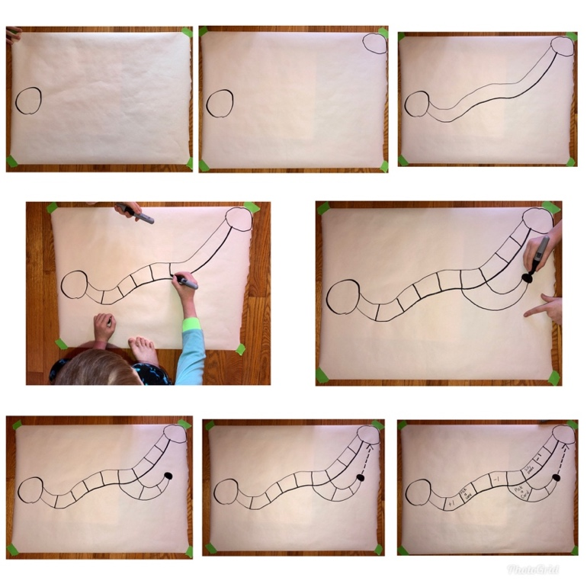

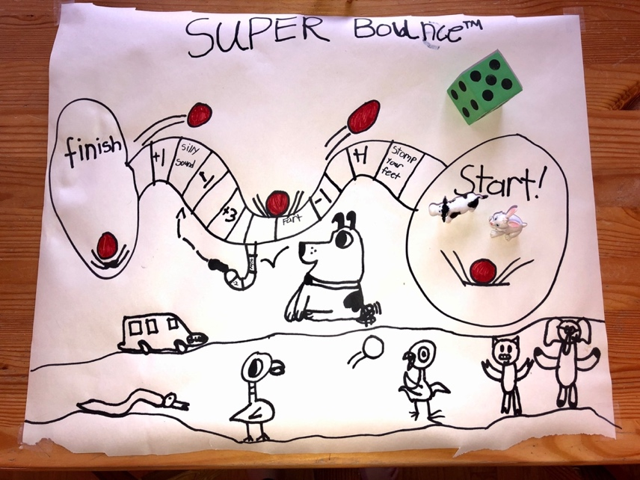

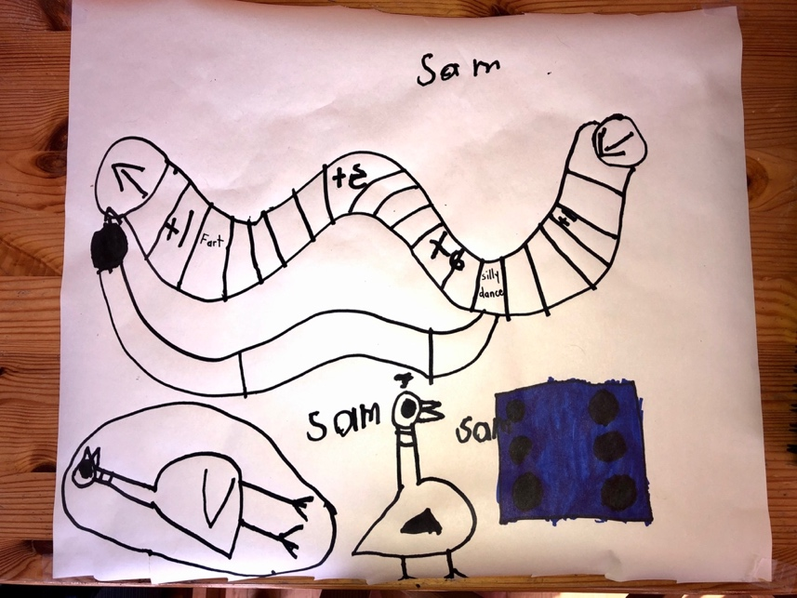

Activity 6
Interview a Community Role Model

You can encourage your children to connect with a member of the community who they admire (a family member, Elder, friend … anyone they choose) and interview them. Help your children decide how to share their interview with others. Some steps for your children to follow are below.

Step 1: Do your research. Listen to other interviews (on TV, Podcasts, Youtube) to think about the kinds of questions you might want to ask!

Step 2: Choose a person you would like to interview and arrange a time. Tip: Ask your interviewee what time works best for them or suggest 2 or 3 possible times. You may also want to provide them with the questions ahead of time.

Step 3: Generate a list of 5 to 10 questions. (Feel free to use questions you have heard in other interviews.). Examples of possible interview questions:
- What is your favourite memory from your childhood?
- What was your favourite music/art as a kid? What made you choose that?
- What was your favourite childhood story? Will you tell me that story? May I share that story?
- What is your favourite sport to play or watch? Do you think it is important for young people to play sports?
- Or create questions specific to their role in the community. Use this link for creating your own questions: https://docs.google.com/file/d/0B7x_ZBobTEDja0RyQWJ4LUpyajg/edit

Step 4: Conduct the interview. Please do so in a safe way! Speaking over the phone or through video would be best, unless the person lives with you.

Tip: Journalists usually record interviews and take notes. If you want to record the interview, ask permission first. If you are taking notes, don’t hesitate to ask your interviewee to repeat something or pause while you make notes. Parents can help children take notes, too.

Step 5: Determine how you will share your interview with friends and family
- Share a video (ONLY if you have permission to do so) (e.g. https://www.youtube.com/watch?v=WAqxc5CALcc)
- Write a newspaper article (e.g. https://nowtoronto.com/music/features/snotty-nose-rez-kids-interview/)
- Create a video using information from your interview showcasing the person you spoke with (ONLY if you have permission to do so) (e.g. https://www.youtube.com/watch?v=g6czQR2RUao)

Activity 7
Outdoor Walk (forest or shore of the ocean, a river, or a lake)

Any outside activities should be considered carefully with safety and well-being in mind,
and depending on whether your Nation has asked people to stay at home.
Please remember to maintain social distancing when you are outside of your house.

The purpose of this activity is to help your children notice things that haven’t caught their attention before, to ask questions about them, and to share their observations. Below are some examples to get started, but open yourself up to observe and notice other parts of nature specific to your community.

Materials:
- Notebook, pencil / pencil crayons / markers etc.
- Camera or smartphone to take pictures (if available)
- A sense of adventure

Forest:
Notice the mosses.
- How many different kinds of moss can you find? Draw each one
- Talk about what is different about them
- What are two questions you have about the mosses?

Notice the branches on the trees and the kinds of needles on them.
- How many different kinds of branches with needles can you find? Draw each one
- Talk about what is different about them
- What are two questions you have about the branches and their needles?

Notice the creek that runs through the forest.
- List three things you notice about the creek
- What are you curious about? List as many questions about the creek as you can
- Share your observations and questions

Shore:
Notice what makes up the shore. Sand? Rocks? Driftwood? Plants?
- What do you notice about the sand or pebbles etc.?. ... Draw what you notice
- Write two questions you have about the sand or pebbles etc.

Notice the Rocks on the shore.
- How many different kinds of rocks can you find? How might you categorize them? Large or small? Smooth or rough? Dark or light?
- Draw one rock from each category
- List one similarity and one difference
- What are two question you have about the rocks?

Notice the driftwood on the shore.
  - What are 3 things you notice about the driftwood?
  - Draw your favourite piece of driftwood
  - What does the driftwood remind you of? (tell someone)
  - What are two questions you have about the driftwood?
  - Talk about your observations and questions

Notice the plants on the shore.
  - What do you notice?
  - What questions do you have about the plants?
  - Where else have you seen these plants?

Other possible activities:
- Your children can harvest traditional medicine, if appropriate, and learn how to properly and respectfully prepare it. Where possible, discuss the benefits of different types of medicines.
- If it is appropriate, your children might reach out to an Elder or community member to learn about how to harvest medicinal plants and where they are located.
- Your children can gather medicines for Elders who are not as mobile, if it can be done safely and delivered later at a time when it is safe to do so.
Activity 8
Activities That Appreciate Family

Families are important for developing a sense of self and a connection to place. You can help your children consider the following projects – and maybe help them implement several of the ideas. You can start by telling your children:

During this time, we will be spending a lot of time together as a family. Here are some ways you can better get to know our family and our family history. Below are a few activities you might consider. Choose 2 or 3 (or maybe all of them!) and keep a daily journal about your experiences and your thoughts about how connecting with family makes you feel.

You may also be able to think of some other fun activities and ways to help other members of our family feel closer in this uncertain time.

- Create a graphic organizer that represents your connections with your family. It could be a chart, a mind map, something else … be creative. You may also want to include your thinking about what families do: they live together, work together, sing together, love each other, celebrate together …

- Prepare foods together. You could call a family member who cooks food you love, and – if the ingredients are handy at home – prepare a recipe with them over the phone or using video chat. You may want to:
- video tape your preparations like you’re on a cooking channel
- create “new recipes” based on what is in the fridge
- try the 100 Mile Diet – only using ingredients harvested within 100 kms
- create new ways to eat fry bread/bannock
- share a meal with the people who live in your household

- Plan a “virtual dinner party.” Send other family members a menu for the night, including recipes if needed. Everyone will prepare the meal in their own homes. Choose an easy meal with ingredients everyone likely has at hand, like spaghetti.
  - Set up a device to allow everyone to be seen and heard on a video call.
  - Prepare some questions or conversation topics ahead:
    - Name one thing you are grateful for
    - What’s a favourite memory about someone at the party?
    - What’s something new I have learned this week?
    - What’s something you are looking forward to?

- Make a “Family Trivia Game.” This is a good activity for learning more about your family history because you can draw on many relatives’ memories and experiences. Brainstorm trivia questions that involve your family. What village did grandma come from? What is auntie’s traditional name? Who is a better hunter – grandpa or uncle? Be creative and have fun! You can also involve people who live in other households if you can connect with them by phone or video chat.

Activity 9
Paper Airplane Science

Your children can have fun and learn all at the same time by turning a simple childhood game into a more formal scientific activity. And why not join in the fun yourself? Who can build a plane that flies the farthest? Expand the learning and time your planes in flight. Whose plane can fly the longest? Let your imaginations soar!!

Step 1: Design and construct 2 paper airplanes. Be creative!

Step 2: Predict which plane will fly farther.

 | Plane A | Plane B
List three different design features of each airplane
Which airplane is more likely to fly farther and why?

Step 3: Design your experiment

- Choose and mark your launching point

- Determine how you will measure the flight path (it needs to be something you can keep consistent, such as the length of your foot, a measuring tape, a book-length, etc.)

- Determine how many times you will launch each plane (we recommend at least 5)

- Create a table to record your data (below is a sample)

 | Trial 1 | Trial 2 | Trial 3 | Trial 4 | Trial 5
Plane A
Plane B

- Determine which plane flew farther in each trial. If you want to challenge yourself, determine the average distance each plane flew (total the distances of each trial and divide by the number of trials). What about the average time they stayed in the air?
- Why do you think one plane flew farther than the other plane? Stayed in the air longer?

- Determine how to share your results
- Create a video or a photo journal that shares your results
- Draw a sketch of the planes that includes a description of the features
- Write a report on your results (include your prediction, observations and conclusion)

- Using what you learned, build new planes that you predict will fly farther and repeat the steps!

Activity 10
Make a Plant Collection

This activity should be considered with the items that you can gather safely.
All outside activities should be considered carefully with safety and well-being in mind.

Step 1: Find 20 different plants. Take a clipping, or dig up the plant and wash / dry the roots.

Step 2: Press the plant between pieces of paper or cardboard. Fold the plant if necessary, but don’t break it. Put weights on top of it.

Step 3: A few days later when the plant is dry, tape each plant on a page to make a booklet. If the plant is too big, tape sections on the page instead.

Step 4: On each page, your child can write the date, time, and location you found the plant, its name, what you know about it, and, if possible, its name in your First Nations language. (Template below)

Step 5: Reflect on the plants you have chosen, considering:
- The importance of the plant to your community and family
- The historical importance of the plant
- How climate change may impact the plant species you have chosen
- Which species are introduced or invasive?

Step 6: Choose a medium to share this new learning. Here are some examples:
- Make a TikTok
- Write a poem
- Create a PowerPoint
- Create a local field guide
- Write a news article

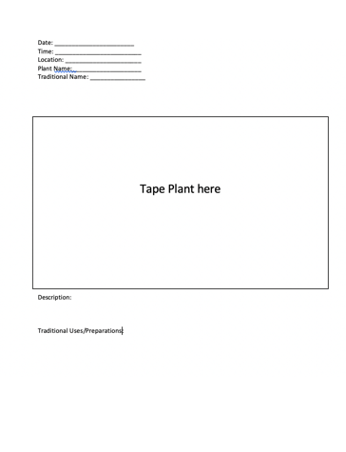

Activity 11
You Be the Critic: Video Game Edition

Step 1: Choose 2 video games

Step 2 : Give each game a rating in each of the categories

- Top Rating
- Lowest Ranking

Game | A. | B.
Graphics
Sound Quality
Music
Storyline
Fun Factor
Playability
Total Controllers

Step 3: Determine the overall game ranking by totaling the columns

1)
2)

Step 4: Write a script for a video describing the game ranked #1. Include evidence related to each of the categories you used to rank the game (graphics, sound quality, music, storyline, fun factor, and playability).

Step 5: Record the video

Step 6: Share the video with your friends and family

You Be the Critic: Snack Edition

Step 1: Choose 5 Snacks

Step 2 : Give each snack a rating in each of the categories

Top Rating
Lowest Rating

Type of Snack
Flavour
Crunch-ability
Smell
Appearance
Fullness Factor
Share-ability
Total Yums

Step 3: Determine the overall snack ranking

1)
2)
3)
4)
5)

Step 4: Write a script for a video describing the snack ranked #1. Include evidence related to each of the categories you used to rank the snack (flavor, crunch-ability, smell, appearance, fullness factor, share-ability).

Step 5: Record the video

Step 6: Share the video with your friends and family

Activity 12
Make Cooking Time, Learning Time

Cooking and baking are great times for learning – for children of all ages.

For younger children:

- Children can help with measuring. What does one cup look like? Half a cup? How do they compare? Which is bigger?
- Children can count the ingredients needed, and learn the important skill of sequencing (what comes first, second, etc.)
- Your children can help you search for recipes based on 1 or 2 key ingredients. Read the recipe together, and make a list of all the ingredients you need to gather.
- Talk about how long the project will take. Talk about whether you think the results will taste good. Are there any ingredients that your children want to know more about?
- Discuss the steps in the process, such as the importance of heating the oven ahead of time, the use of yeast, why wet ingredients are added to dry ingredients, whether family members like different kinds of foods, how different kinds of foods are important to your community, etc.

For older children

- Have your children plan an actual or imagined meal.
- Children can look for recipes online or in books. Have them think about the ingredients involved. Do you have them on hand? Will they be hard to get? How much time will it take to cook the meal? Will it be easy or difficult to make?
- More advanced children can analyze the ingredients, by looking at the labels if they are in the house or by using the internet. How nutritious is the meal? How many grams of protein, fiber, fat, sugar, calories are in the ingredients.
- Your children can list the amount of ingredients needed – for the recipe as it is written, or for twice the recipe to serve more people (to practice math skills)
- What will the necessary groceries cost (this can be determined by checking an online shopping service)
- Your children can create a time schedule for preparing and cooking of each part of a meal
- What things need to be done, in what order?
- Ask your children to think scientifically.
- What makes ingredients, or combination of ingredients, change from one state to another (e.g. melting butter: solid to liquid; freezing water: liquid to solid)
- What happens when different ingredients are heated? Do they react differently?

Activity 13
Practicing Personal Responsibility

Cleaning, Organizing, and Daily Chores
- Your children can create a family chore chart to practice writing and organizational skills
- They can practice reading, writing and sorting by making labels for storage bins and planning for the storage of items. For example, what items work best in which location, based on the size of the item(s) and the space available?

Scheduling
- Helping to plan daily and weekly schedules teaches important personal development skills. Children can consider:
- When do I normally do things on a school day?
- When do I have the most energy and should spend some time outside?
- When would be a good time for me to sit quietly and read a book?
- What are some skills I really want to learn but have never had the time to practice?

- Children can think about and track time spent on tasks. Using a clock, children can develop math skills such as fractions (“that took half an hour”; “each task took then minutes so the five tasks took 50 minutes in total”; “that task took 30 minutes; what percentage of my day did I spend doing that?”).

Gardening
- Planting and maintaining a garden or houseplant can include thinking about the best location, a watering schedule, etc.
- Children can help with planting, watering, weeding, etc. to practice responsibility
- Children can make predictions, such as which plants will grow the quickest, how tall the plants will grow, etc.

Activity 14
You Be the Star

Share the following idea for your children to practice planning and organization skills.

Create a video to share your learning on social media! You have been doing lots of fun activities at home. Now it is time for you to show off your learning. Use the organizer below to plan a video to share with your friends and family. Feel free to use whichever platform you like.

But make sure to get permission from your family before posting

Tip #1 - Write point form notes about what you want to say and do

Introduction (Tell the audience who you are, where you are from, and what you are going to share)
Scene #1 (Include the location, any special effects, and important information you will share)
Scene #2 (Include the location, any special effects, and important information you will share)
Conclusion (Restate the purpose of your video and the cool things you learned. Thank everyone for watching)

Tip #2 – Do your research. There are lots of “how-to” videos that can help you add interesting effects or use editing to create engaging illusions. Get creative!

Here is a sample outline! Feel free to make this video if you want!

Introduction
- On stairs
- “Hi, I’m Brody!” Jump down two steps. “I’m going to show you how to skip count”
Scene #1
- Start at the bottom of the stairs
- “I’m going to skip count by 5’s! Each time I go up a stair I count by 5.”
- Count all the way to 50
Scene #2
- Start at the top of the stairs
- “Now I’m going to skip count by 3’s! Each time I go down a stair I count by 3.”
- Count all the way to 30
Conclusion
- “Thanks for watching me skip count! Now it’s your turn! Make a skip counting video and tag me in it. Can’t wait to see you counting too! I challenge Shawn, Cecilia and Peter”

Activity 15
Make a Photo Collection - Basic Photo Composition

Please feel free to share the following activity for older children
who have access the the Internet and a camera, phone or tablet available for use.

Step 1: Log on to www.ck12.org. Click on “Photography.” Choose the photography icon and click on it.

Step 2: From “Overview” choose #2. Basic Photo Composition. Four different techniques are listed.

2.1. Framing Photographs
Questions to think about:
- What is framing?
- How does framing affect your eye when you look at a photo?

2.2. Point of View
Questions to think about:
- How does point of view change the way you view the subjects and their locations?
- How is the effect of a low point of view different from the effect of a high point of view?

2.3. Lines, Texture and Pattern
Questions to think about:
- What is a pattern in a photograph?
- What are some examples of objects that create lines in photographs?
- What are some good examples of textures outside that can add interest to a picture?

2.3. Level Horizon
Questions to think about:
- What is a level horizon?
- Why is a level horizon important?
- How does the rule of thirds apply to a level horizon?

Step 3: Read each section, study the examples, and then go out and create photos using the tips you learned. Write journal entries to describe how you set up the shot and list the equipment or materials you used to create the perfect photo. Number your journal entries to match the photo(s). Remember: keep trying until you get the perfect shot.
- Erase and repeat.
- Try different times of day, inside or outside.
- Be a detective in your environment and notice things big and small.

Step 4: Create a portfolio of your photos separated according to each technique. Label your photos according to the journal numbering system, so others can read and learn about your techniques as they go through your portfolio. Have fun and try more than one technique at a time! Ask your family to help set up your shots, and teach them how to take great photos, too.
Activity 16
Create a Cell
(a three day project)

This is a fun learning activity to share with older children. Join in as much as you want to, so you can enjoy the activity yourself and to discuss the learning with your kids.

Purpose: In this project, students will create a “cell” by dissolving the shell of a chicken egg. Once the shell is dissolved, a thin membrane, permeable to water, is all that remains holding the egg intact. Since our cells are made of around 60% water, we can use this “cell” to study the effects of different types of solutions on our bodies.

Materials: 3 eggs, 3 L of vinegar, ½ cup of table salt, 3 large containers (approx. 500 mL), scale (optional), string (30 cm), ruler, paper towel.

Procedure:
1. Place one egg in each of the 3 containers and completely submerge the eggs in vinegar. Bubbles will begin to form on the egg as the shell dissolves. After 24 hrs, drain the vinegar and submerge the egg in fresh vinegar. After 48 hours, the shell of the egg should be completely dissolved. Drain the vinegar, pat the eggs dry and rinse out the containers. Be very careful with your eggs as they will be extremely delicate. Leave the eggs sitting on paper towel until the solutions are ready.

2. Fill each of the three containers ¾ full with water. Label one container “A,” the next “B,” and the third “C”. Into container A, place ½ tsp of salt and stir until dissolved. Into container B, place the remaining salt and stir until as much dissolves as possible. Leave container C as just water. Each of the solutions will represent various types of solutions in our environment. Fill in the table below to remember which was which.

Solution | What did we put in? | Types of solutions represented
A |  | Blood, saline solution, milk
B |  | Ocean water, saturated solutions
C |  | Water

3. Carefully wrap a piece of string around the widest part of the first egg. Then measure the length of string. Place the egg into solution A. Make sure to record the length in Table 2 on the next page under “Starting Distance Around (cm)”. If you have a scale, you can also measure the mass of the egg. We will use the changes in these measurements to study the effects of each solution. Repeat this process for the other two eggs. Make sure that the measurements for the second egg are recorded under solution B and the third egg for solution C.

4. Leave the eggs soaking in their solutions for 24 hours. Record your predictions in Table 1. What do you think will happen to each egg?

5. Remove the eggs from the solutions and pat dry with paper towel. Place the egg on the towel and in front of its container so that you remember which belongs to which. Measure the distance around (and the mass if possible) and record under “Final Distance Around” for each egg.

6. To calculate the change in each measurement, subtract the final from the starting measurement.

7. Answer the concluding questions.

Data:

Table 1: Predictions

Solution | What do you think will happen to each egg?
A
B
C

Table 2: Measurements

Solution | Starting distance around (cm) | Starting mass (g) | Final distance around (cm) | Final mass (g) | Change in distance around (cm) | Change in mass (g)
A
B
C

Concluding Questions:

1. Were your predictions correct? If yes, great job! If not, great job as well, but think about why your predictions were different from the results.
2. What substance do you think the eggs gained or lost, causing the change in their size/mass?
3. How does this activity explain why drinking ocean water can be fatal if too much is consumed?
4. Does this activity demonstrate the dangers of drinking too much water?
5. Tomorrow, write down how much water you drink thoughout the day and think about which type of solution your cells are sitting in. Too much water? Or too little?
Activity 17
Critical Thinking About a Call to Action

You can encourage your older children to practice their critical thinking and analysis skills by using the activity described below. This is a great way for students to reflect on an issue they find interesting and motivational, and think about how they can persuade other people to make a positive difference.

Step One: Ask older children to think about a challenging issue they are familiar with, or research a challenging issue using the Internet, if they have connectivity.
Some ideas to think about.
- Is vegetarianism a good option?
- Should fighting be banned from hockey?
- Was it a good idea to do away with the penny?
- Should parents or other adults be able to ban books from schools and libraries?
- Should bottled water be banned?
- Is human activity a substantial cause of global climate change?
- Should Halloween be moved permanently to Saturday?
- Do violent video games contribute to youth violence?
- Should zoos exist?
- Anything else that they find interesting and motivational.

Step Two: Have your children write their opinions about the issue and the reasons they hold those opinions. Then ask them to make a list of specific actions people can take to address the issue.

Step Three: Your children can write a 'call to action' letter about the issue that includes their position, why individuals should act, and at least three things people can do to help.

Activity 18
Critical Thinking About a Call to Action

You can encourage your older children to practice their critical thinking and analysis skills by using the activity described below. This is a great way for students to reflect on an issue they find interesting and motivational, and think about how they can persuade other people to make a positive difference.

Step One: Ask older children to think about a challenging issue they are familiar with, or research a challenging issue using the Internet, if they have connectivity.
Some ideas to think about.
- Is vegetarianism a good option?
- Should fighting be banned from hockey?
- Was it a good idea to do away with the penny?
- Should parents or other adults be able to ban books from schools and libraries?
- Should bottled water be banned?
- Is human activity a substantial cause of global climate change?
- Should Halloween be moved permanently to Saturday?
- Do violent video games contribute to youth violence?
- Should zoos exist?
- Anything else that they find interesting and motivational.

Step Two: Have your children write their opinions about the issue and the reasons they hold those opinions. Then ask them to make a list of specific actions people can take to address the issue.

Step Three: Your children can write a 'call to action' letter about the issue that includes their position, why individuals should act, and at least three things people can do to help.

