Activity 5
Rock / Paper / Scissors Ratios

Rules

- There are 2 players. Each player chooses “rock, paper, or scissors,” but does not tell the other player what they chose.
- Each player forms his or her hand in a fist. Players shake their fists 3 times. Then the players use their hand to demonstrate the chosen item:

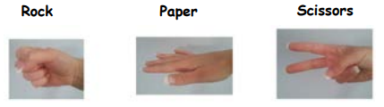

- Rock beats scissors. If one player chose rock and the other chose scissors, rock wins.
- Scissors beats paper. If one player chose scissors and the other chose paper, scissors wins.
- Paper beats rock. If one player chose paper and the other chose rock, paper wins.
- If both players choose the same item, this results in a tie.

Play the game several times. After each round record your results on the following chart.

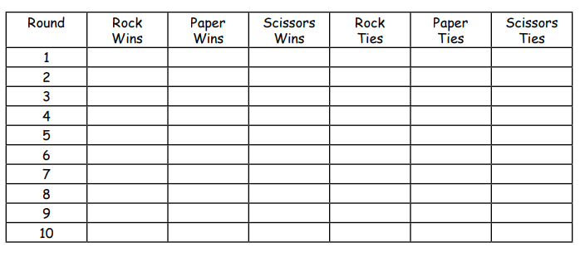
Once your data has been recorded, answer the following questions.

- Write the ratio of wins for each type in the order ROCK : PAPER : SCISSORS. Make sure your ratio is in lowest terms. For example, if the ratio was 8: 6: 4, you would change it to 4: 3: 2, by dividing each number by 2.

- Which item had the most wins? Why do you think this was?

- If you did this activity a second time, would you get the same results?

