Activity 8
Connecting Adult Learners to Khan Academy

Khan Academy is a great site for students of all ages – including adults. Adults can play around with the site and find the level that best suits them.

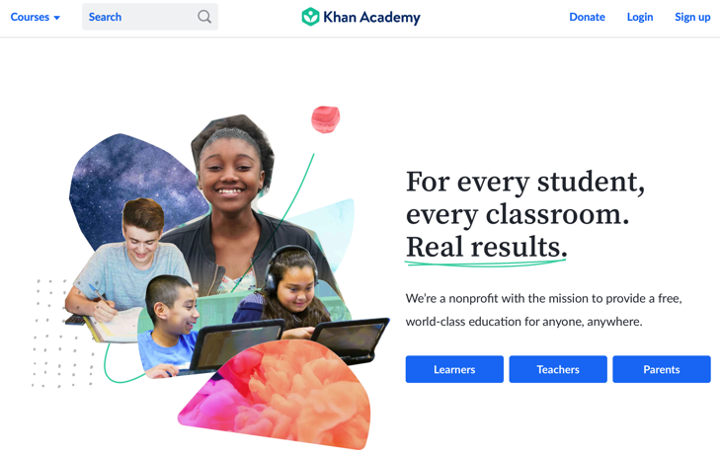 | Step 1: Sign up as a learner
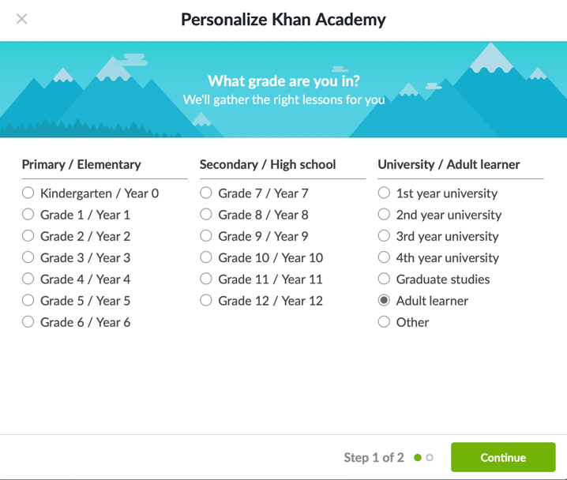 | Step 2: Select Adult Learner
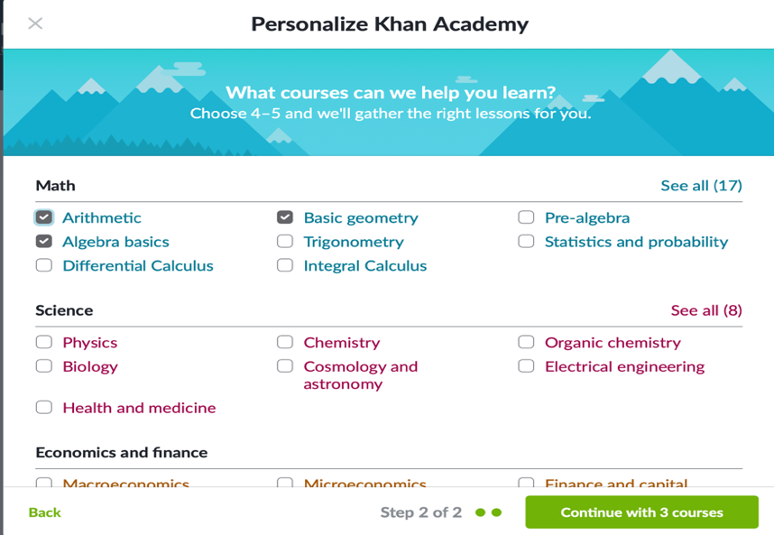 | Step 3: Select the relevant courses.
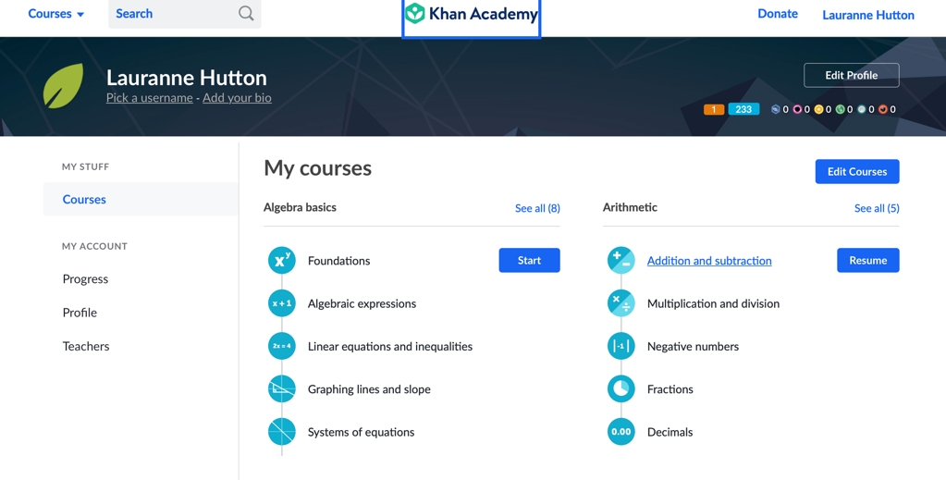 | Step 4: Select the area of focus.
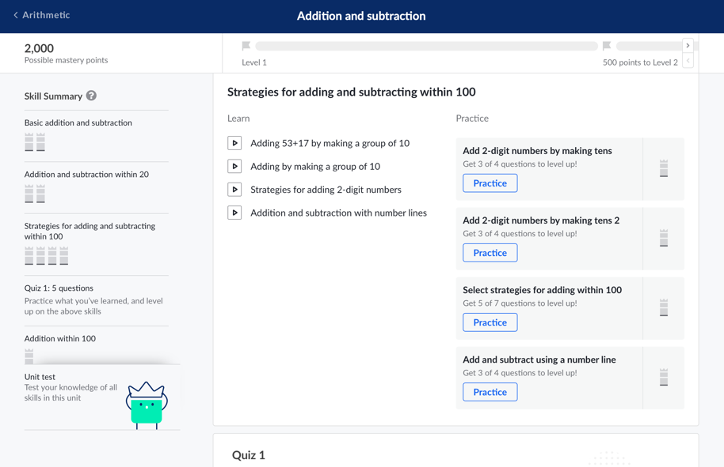 | Step 5: Scroll through the course and choose an appropriate starting point. Starting from lesson one and working all the way through is a great idea. If the work is too easy, skip ahead.
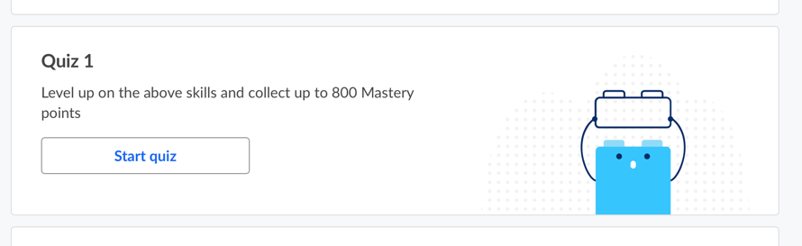 | It may also be useful to start taking quizzes and begin the lessons at the point where the quiz becomes too tricky.

Happy Learning!

