SUGGESTIONS FOR CONTINUOUS LEARNING
SECOND EDITION

APRIL 23, 2020

THIS IS THE SECOND EDITION OF OUR SUGGESTIONS FOR CONTINUOUS LEARNING,
PROVIDING NEW IDEAS FOR CONSIDERATION.

EDITION ONE IS AVAILABLE AT http://www.fnesc.ca/march-27-2020-update/

SUGGESTIONS FOR FAMILIES: SUPPORTING LEARNING AT HOME IS AVAILABLE AT
http://www.fnesc.ca/covid19/supporting-learning-apr14-2020/

A web version of Editions 1 and 2 is at http://www.fnesc.ca/continuous-learning/

Recognizing that First Nations have authority for the education of their citizens, including having full responsibility for their own schools, how First Nations choose to address continued learning while their schools are closed will vary from community to community. Within that context, this document is intended to provide remote learning suggestions that teachers and education leaders can adapt and share with their families and students through mechanisms that best suit their particular circumstances.

FNESC and FNSA fully respect the authority of each First Nation to make decisions about the continued operations of their schools and staff during this time of change. We also recognize that community and school representatives best understand local needs, circumstances, and decisions, including varying levels of family access to resources, technology, and connectivity, and differing opportunities for community and school staff to provide learning materials to students and families who might be restricted to their homes.

FNESC and FNSA acknowledge that it is up to First Nations to determine whether:
- school staff should continue working while classes are suspended, and if so whether in school or from home;
- all school and community facilities should be closed, including outdoor parks and playgrounds;
- school staff should be phoning / emailing / texting students and families directly; and
- packages of learning materials can be safely provided to families and students.

All of those factors will impact on what remote learning activities are possible.

These suggestions are intended to be adapted and used as appropriate to benefit students and families in varying contexts. We welcome ideas for other activities.

Considerations for the Suggested Continued Learning Opportunities

- First Nations leaders across Canada have announced that their communities are in a state of emergency. In this situation, while remote learning activities can be valuable and beneficial for students and families, the health of First Nations citizens (both physical and mental) and community safety are the primary priorities.
- Many First Nations are requesting that only people in one household should be together. Any First Nation directives regarding self-isolation / possible lock-down procedures must be respected first and foremost.
- In these challenging times, it is particularly important to encourage parents, children and other family members in the same household to enjoy quality time together at home.
- Any recommended remote / home learning activities should not become a source of anxiety for students and families; student and family mental and emotional well-being cannot be compromised by introducing additional stress through overly prescriptive or unrealistic learning expectations.
- It is not feasible to replicate a school day while school is suspended and children cannot gather together with teachers and other school staff.
- Home learning activities must be reasonable; they should not require excessive time and resources that not all families will have available. Suggested activities should not encourage families to leave their homes to access supplies.
- All activities must be safe for everyone involved. Home learning activities should not require students / parents gathering with people from different households.
- Home learning activities will ideally be of interest to parents and students, and they should be enjoyable and hands-on as much as possible.
- Cultural activities and language learning opportunities can be an important part of suggested home learning activities.
- Technology equipment and internet access may be limited in some homes, and on-line options cannot be relied on as the only remote learning option. Teachers may be able to connect with families and students on-line, or by email, through Facebook or other social media, by telephone, or through text messaging in order to offer support and guidance.

Suggested Remote Learning Activities

The following are suggestions for engaging and easy to implement activities that educators can share with families and students. They are designed to support remote learning opportunities while schools are not in session.

FNESC staff also are available to assist First Nations school educators and education leaders in discussing remote learning opportunities and how they connect to the curriculum, including helping with ideas that: are easy to implement; can be undertaken in a range of circumstances; and respect the importance of families supporting one another and enjoying time together, especially during stressful circumstances. Please feel free to contact FNESC staff by email or phone for further assistance.

ADDITIONAL SUGGESTED LEARNING RESOURCES AVAILABLE ONLINE

- Keeping Kids Active During the Pandemic, created by the First Nations Health Authority, shares fun activities to keep young children active and engaged while at home. https://www.fnha.ca/WhatWeDoSite/CommunicableDiseaseControlSite/PublishingImages/what-we-do/communicable-disease-control/coronavirus/public/keeping-kids-active-during-the-pandemic.pdf?fbclid=IwAR3n9k_wuxGo7s9U_9Lx6coAhgzCFdtJn53tLCwPhURyIiolVeCVK0gvSQE

- PBL Project has a wide selection of fun and educational STEM challenges for students of all ages. http://pblproject.com/page.aspx?pageid=Remote-Learning_STEM-Challenges

- IXL offers skill practice in all areas of math and at all grade levels. Parents can sign up for a free 30 day membership. www.ca.ixl.com

- The FNESC and FNSA Connected Classrooms Program moodle site includes a number of continuous learning activities for high school and adult students. http://classroom.fnesc.ca/moodle/. All First Nations schools are welcome to access this information while classes are suspended. The Connected Classrooms teachers also are available to provide educators with support delivering their resources. BC First Nations schools can request login details from lauranneh@fnesc.ca

- Audible stories at https://stories.audible.com/start-listen keep children engaged and learning by listening. This is a good activity to use in conjunction with crafting or creating art. Great for students of all ages – including adults.

- The web site of JABC, a non-profit that delivers business education programs in schools across the province, includes activities that focus on financial literacy, work readiness and entrepreneurship for grades 4 – 12. https://jabc.ca/online-learning/

- At https://www.storylineonline.net/, watch and listen to read-aloud stories on this engaging and entertaining web site. Some books have activity guides for parents and teachers. Good for grades K- 4

- PBS Learning offers free educational videos, interactives, lesson plans, and more. Create lessons, quizzes and activities with any of the resources. Good for learners of all ages. https://www.pbslearningmedia.org

- www.virtualmuseum.ca offers virtual tours and an online experience for exploring historic and cultural heritage sites, as well as exhibits. This is a good site for grade 4 - 12 students and adults.

- For older students, the award winning ProCon.org website promotes critical thinking, education, and informed citizenship by presenting controversial issues in a straightforward, nonpartisan, and primarily pro-con format. Teacher lesson plans are included on the site.

- Connected North @ Home is providing 4 - 6 daily Connected North sessions for students/families to access directly at home. Topics include such things as Deep Sea Animals, Music and Movements, Narwals and Unicorns, You Are What You Eat, Life Under the Microscope, etc. The web site with links to join live is: http://connectednorth.org/athome. Recordings are available online at http://videos.connectednorth.org and on dedicated apps for Apple TV, Roku and Fire TV!

- Create to Learn @ Home is an at-home training initiative in partnership with imagineNATIVE to support student learning at home. These video tutorials on digital skills and/or traditional knowledge using digital tools are all created by First Nations, Métis and Inuit artists and media makers to share their skills with students. Anyone interested can explore the videos online here - with TV apps coming soon! http://videos.createtolearn.ca

Additional resources for sharing with students or families are attached.

Activity 1
Defending Your Position
Binge-Watching Sample
(good for grade 8-12 & adult students)

An essential academic learning for students who are preparing to continue their education or begin participating more fully in local and broader society is the ability to argue a point using evidence. This activity has been developed to promote that type of learning.

Step 1
Have students go to www.procon.org. Scroll down to the heading Entertainment and Sports. Go down the list and click on “Binge-Watching.”

Step 2
Have students read the pros and cons on the web site and think about the questions posed below to develop their own opinion about the topic.

Things for students to think about:

- Do you prefer watching several episodes of a new show all at one time, or one episode per week? How does your viewing experience change if you binge-watch?
- What reasons might explain why some streaming services like Netflix drop a full season at once? Why might a service such as Disney+ post just one episode per week?

Step 3
Ask students to make a “My Opinion” video that explains their position on binge watching.

Students can think about the pros and cons of binge-watching, what position they find most convincing, and why.

Step 4
Encourage students to invite their family or friends to watch their video and participate in a discussion about this topic.

Possible Additions

Students can individually complete the steps above to form their own opinions, and then other students can watch each video and take notes to prepare for a group discussion.

Many other topics can be found on www.procon.org with pro and con ideas to consider.

Activity 2
Create a Cell
(a three day project)

This is a fun learning activity to share with older students.

Purpose: In this project, students will create a “cell” by dissolving the shell of a chicken egg. Once the shell is dissolved, a thin membrane, permeable to water, is all that remains holding the egg intact. Since our cells are made of around 60% water, we can use this “cell” to study the effects of different types of solutions on the human body.

Materials: 3 eggs, 3 L of vinegar, ½ cup of table salt, 3 large containers (approx. 500 mL), scale (optional), string (30 cm), ruler, paper towel.

Procedure:
1. Place one egg in each of the 3 containers and completely submerge the eggs in vinegar. Bubbles will begin to form on the egg as the shell dissolves. After 24 hrs, drain the vinegar and submerge the egg in fresh vinegar. After 48 hours, the shell of the egg should be completely dissolved. Drain the vinegar, pat the eggs dry and rinse out the containers. Be very careful as the eggs will be extremely delicate. Leave the eggs sitting on paper towel until the solutions are ready.

2. Fill each of the three containers ¾ full with water. Label one container “A,” the next “B,” and the third “C”. Into container A, place ½ tsp of salt and stir until dissolved. Into container B, place the remaining salt and stir until as much dissolves as possible. Leave container C as just water. Each of the solutions will represent various types of solutions in our environment. Fill in the table below to remember which was which.

Solution | What did we put in? | Types of solutions represented
A |  | Blood, saline solution, milk
B |  | Ocean water, saturated solutions
C |  | Water

3. Carefully wrap a piece of string around the widest part of the first egg. Then measure the length of string. Place the egg into solution A. Make sure to record the length in Table 2 on the next page under “Starting Distance Around (cm)”. If you have a scale, you can also measure the mass of the egg. We will use the changes in these measurements to study the effects of each solution. Repeat this process for the other two eggs. Make sure that the measurements for the second egg are recorded under solution B and the third egg for solution C.

4. Leave the eggs soaking in their solutions for 24 hours. Record your predictions in Table 1. What do you think will happen to each egg?

5. Remove the eggs from the solutions and pat dry with paper towel. Place the egg on the towel and in front of its container so that you remember where each belongs. Measure the distance around (and the mass if possible) and record under “Final Distance Around” for each egg.

6. To calculate the change in each measurement, subtract the final from the starting measurement.

7. Answer the concluding questions.

Data:

Table 1: Predictions

Solution | What do you think will happen to each egg?
A
B
C

Table 2: Measurements

Solution | Starting distance around (cm) | Starting mass (g) | Final distance around (cm) | Final mass (g) | Change in distance around (cm) | Change in mass (g)
A
B
C

Concluding Questions:

1. Were your predictions correct? If yes, great job! If not, great job as well, but think about why your predictions were different from the results.
2. What substance do you think the eggs gained or lost, causing the change in their size/mass?
3. How does this activity explain why drinking ocean water can be fatal if too much is consumed?
4. Does this activity demonstrate the dangers of drinking too much water?
5. Tomorrow, write down how much water you drink thoughout the day and think about which type of solution your cells are sitting in. Too much water? Or too little?

Activity 3
Critical Thinking About a Call to Action

This activity is intended to encourage older students and adult students to practice their critical thinking and analysis skills, by asking them to reflect on an issue they find interesting and motivational, and how they can persuade other people to make a positive difference.

Ask older students to think about a challenging issue they are familiar with, or research a challenging issue using the Internet, if they have connectivity.

Some ideas to think about.
- Is vegetarianism a good option?
- Should fighting be banned from hockey?
- Was it a good idea to do away with the penny?
- Should parents or other adults be able to ban books from schools and libraries?
- Should bottled water be banned?
- Is human activity a substantial cause of global climate change?
- Should Halloween be moved permanently to Saturday?
- Do violent video games contribute to youth violence?
- Should zoos exist?
- Anything else that they find interesting and motivational.

Have the students write their opinions about the issue and the reasons they hold those opinions. Then ask them to make a list of specific actions people can take to address the issue.

The students can also write a 'call to action' letter about the issue that includes their position, why individuals should act, and at least three things people can do to help.

Activity 4
Chemical Reactions at Home!

In this activity, students will use baking soda and vinegar to study how chemical reactions occur. Many students may have used baking soda and vinegar, but have they tried to catch the bubbles?

Materials:
1 narrow neck bottle (approx. 500 mL), vinegar (1 L minimum), baking soda (1/2 cup minimum), 1 regular sized balloon, tape (duct or masking tape will do), string (50 cm), a ruler

Procedure:
1. Place ½ cup of vinegar into the bottle
2. Blow up and then deflate the balloon to stretch it out.
3. Carefully place ½ teaspoon of baking soda into the balloon – using a funnel if available.
4. Carefully stretch the opening of the balloon over the opening of the bottle. Make sure the baking soda stays inside the balloon during this step.
5. Seal the balloon to the bottle using tape.
6. Lift up the balloon to empty the baking soda into the bottle.
7. Once the reaction is complete (no more bubbles are forming), wrap string around the widest part of the balloon to measure its circumference. Record this number in Table 1. The measurements in Table 1 will be the standard measurement for comparison with all others.
8. Assuming that the shape of the balloon is a sphere, we can calculate the radius. Use the formula $r= \frac{C}{2π}$. Record this radius in Table 1.
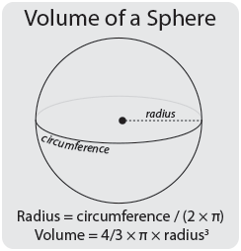
9. We can calculate the volume of the balloon using the formula V = $\frac{4πr^{3}}{3}$
10. Remove the tape from around the bottle and empty everything out to prepare for the second trial.
11. To fill in Table 2 and 3, double one of the reactants and predict how the volume of the balloon will change.
- In Table 2, double the amount of baking soda used, then repeat the steps.
- In Table 3, double the amount of vinegar used, then repeat the steps.
12. Complete the conclusion questions to analyze the results.

Data:
Table 1

Circumference | Radius | Volume

Table 2

Prediction (How will the volume change? Will it increase? decrease? double? half?) | Circumference (cm) | Radius (cm) | Volume (cm³)

Table 3

Prediction (How will the volume change? Will it increase? decrease? double? half?) | Circumference (cm) | Radius (cm) | Volume (cm³)

Conclusions (answer on a separate piece of paper)
1. Were any of your predictions correct? If not, why do you think the results were different than you thought?

2. Which reactant do you think has the greatest effect on the volume of gas produced? What evidence makes you think so?

3. Predict what would happen to the volume of gas produced if you doubled both of the reactants at the same time. If you have time and enough materials, check if you are right!

Activity 5
Rock / Paper / Scissors Ratios

Rules

- There are 2 players. Each player chooses “rock, paper, or scissors,” but does not tell the other player what they chose.
- Each player forms his or her hand in a fist. Players shake their fists 3 times. Then the players use their hand to demonstrate the chosen item:

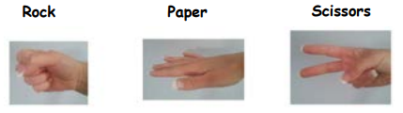

- Rock beats scissors. If one player chose rock and the other chose scissors, rock wins.
- Scissors beats paper. If one player chose scissors and the other chose paper, scissors wins.
- Paper beats rock. If one player chose paper and the other chose rock, paper wins.
- If both players choose the same item, this results in a tie.

Play the game several times. After each round record your results on the following chart.

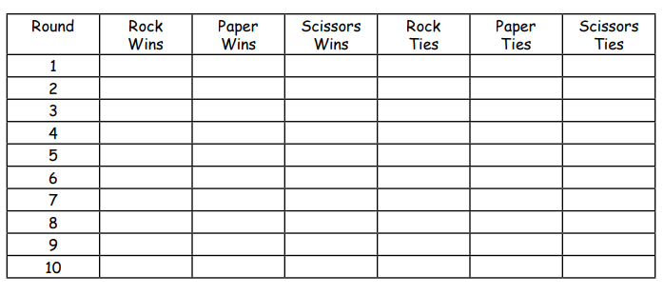
Once your data has been recorded, answer the following questions.

- Write the ratio of wins for each type in the order ROCK : PAPER : SCISSORS. Make sure your ratio is in lowest terms. For example, if the ratio was 8: 6: 4, you would change it to 4: 3: 2, by dividing each number by 2.

- Which item had the most wins? Why do you think this was?

- If you did this activity a second time, would you get the same results?

Activity 6
Ethnobotany

Any outside activities should be considered carefully with the safety and well-being of participants in mind,
and recognizing any related First Nations’ directives about staying at home.

This activity and the guiding questions are based on the FNESC resource “Science First Peoples Teachers Resource Guide http://www.fnesc.ca/sciencetrg/ and the lesson plans offered at the BC Royal Museum https://learning.royalbcmuseum.bc.ca/wp-content/uploads/2019/03/Native-Plants-Lessn-Plan.pdf

Plant based inquiry
“Traditional Ecological Knowledge about the diverse plants growing in their territories is key to the sense of place for First Peoples. When First Peoples go out on the land to pick berries, to dig bitterroot, to gather stinging nettle, bark or grasses, it provides a connection with the land and with the ancestors. This activity can teach students of all ages a connection with the land, and the traditional knowledge connected with the land.”

If it is possible to do so safely, go for a walk in your neighbourhood, or have a parent take you out in the territory. Pay particular attention to the plants you see. Try to choose one specific plant that you find most interesting, and start investigating it, thinking about the following questions.

- What is the plant? What is its name? What is its traditional name?
- Is this plant used for food or for shelter? Or for making materials out of it? What do you know about this plant?
- If you can take a picture, make a sketch based on the photo. If appropriate and only if you can respectfully harvest a sample, take it home and draw your specimen.
- Can you find out what this plant is called in your language? Can you find out more about its traditional uses and how these uses are spoken about in your language? You might begin investigating this by looking it up at FirstVoices.com, or you might also contact an Elder or Knowledge keeper by phone or email to answer your questions. Ideas for closer investigation using the example of Salmonberry are below. You could think about:
  - What do we call Salmonberry in our language?
  - When are Salmonberries harvested? What do we call that season in our language?
  - Do I have a favorite traditional dish that includes Salmonberry? What is it called?
  - Are other parts of the Salmonberry plant used? What is the name of these parts in our langage (e.g. leaves, roots)
  - Where in our territory does Salmonberry grow? Does this place have a special name in our language?
  - Are there any traditional stories about salmonberries? Or songs?
  - How are the berries preserved?

Extensions

Students can choose a different plant each week and compile a personal ethnobotany guide to their immediate surroundings. The guide can include sketches, observations, language, and information about traditional stories, songs and uses.

Younger students can play Backyard Bingo while doing this activity:
https://learning.royalbcmuseum.bc.ca/wp-content/uploads/2020/03/Backyard-Bingo-1.pdf

For further reading, photos for plant identification, and activities, also look at this website at the Royal BC museum: https://learning.royalbcmuseum.bc.ca/pathways/native-plants-south-coast/

Activity 7
At-Home Language Learning Lesson

This idea might be useful for beginner/novice level language learners
It is a self-led / independent activity

Many students and families are at a beginner level of language learning. At this level, learners may be able to identify words, phrases and some simple greetings, but they cannot yet use their language in a sentence or maintain a conversation.

The first objective when learning a language is to listen to it and begin to understand what is being spoken to you. Repetition and exposure is key! It leads to a growing comprehension of some of the language heard.

This activity is meant to facilitate that experience.

Learning objectives:
- Hear sounds, patterns and familiar words/phrases in your ancestral language.
- Record and share a greeting, song, or prayer in your language that you have already learned and practiced.

Parents can be asked to:
- Ask their child if they remember a greeting, song or prayer they learned at school.
- Ask them to practice what they learned and share it with you.
- Optional: children can be asked to record a video to share with others or to share with the teacher.

* Sharing / teaching another person something in their language helps students to reinforce what they have already learned and celebrates what they know!

Below are some other options that will help children hear their language in the home environment, knowing that exposure to their language, however possible, as much as possible, is key to learning the language. It also helps if students are encouraged to identify patterns and repetition in stories, songs, and recordings

Option A: Set-up a call or video chat with a fluent speaker in your family (grandparent, aunt, uncle)

Option B: Find words, phrases, stories and songs on https://www.firstvoices.com/

Option C: Search YouTube to find videos of songs, stories and lessons in your language

Option D: Request a call or video chat with your child’s language and culture teacher to ask for beginner language lessons they’ve developed

Good luck and have fun learning your language as a family!

Activity 8
Connecting Adult Learners to Khan Academy

Khan Academy is a great site for students of all ages – including adults. Adults can play around with the site and find the level that best suits them.

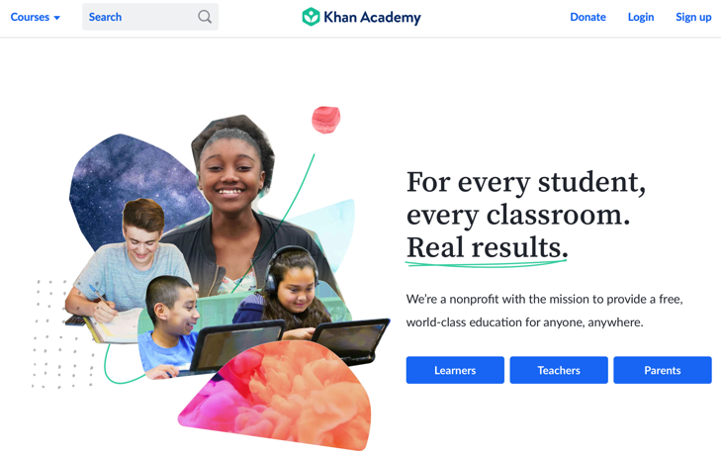 | Step 1: Sign up as a learner
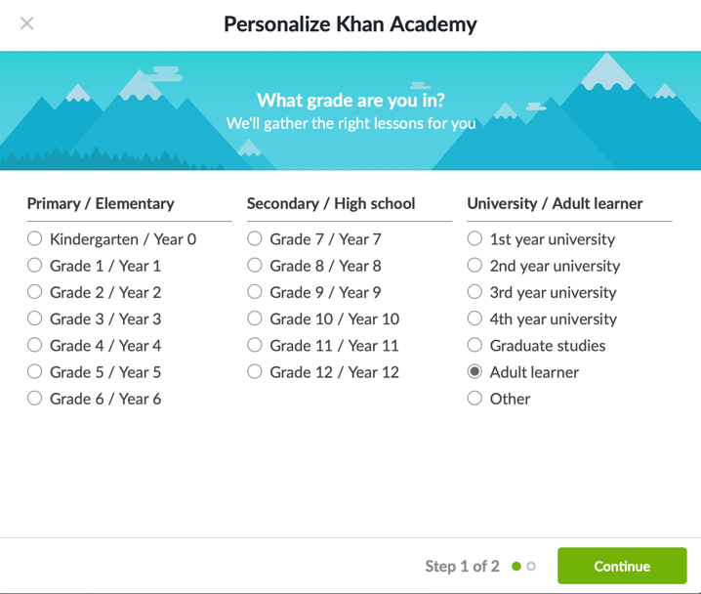 | Step 2: Select Adult Learner
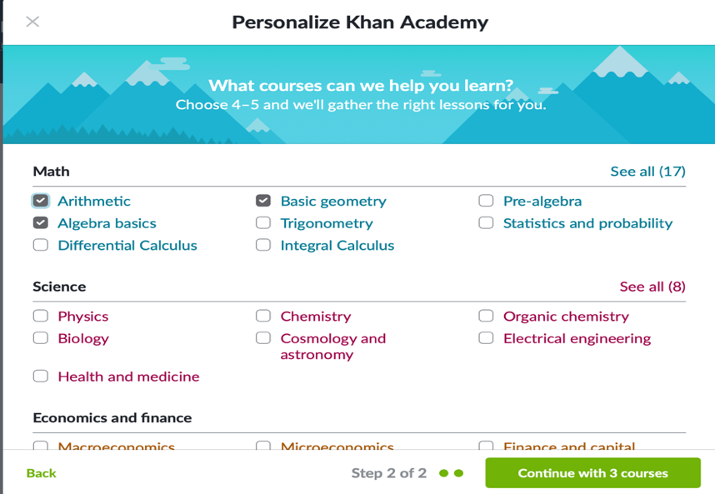 | Step 3: Select the relevant courses.
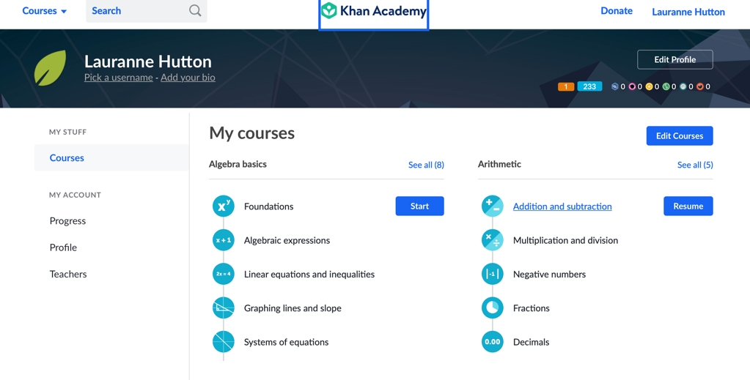 | Step 4: Select the area of focus.
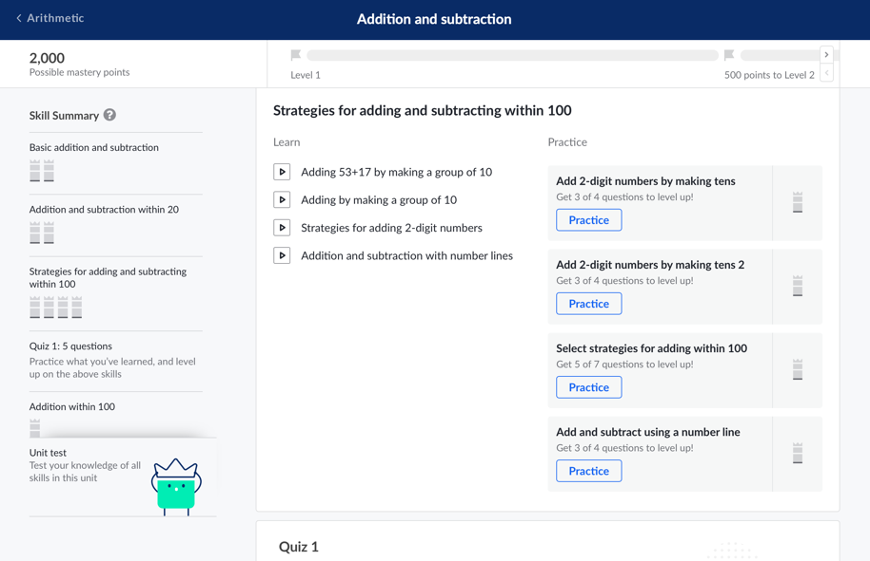 | Step 5: Scroll through the course and choose an appropriate starting point. Starting from lesson one and working all the way through is a great idea. If the work is too easy, skip ahead.
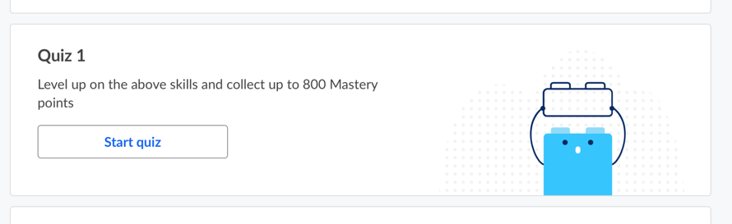 | It may also be useful to start taking quizzes and begin the lessons at the point where the quiz becomes too tricky.

Happy Learning!

